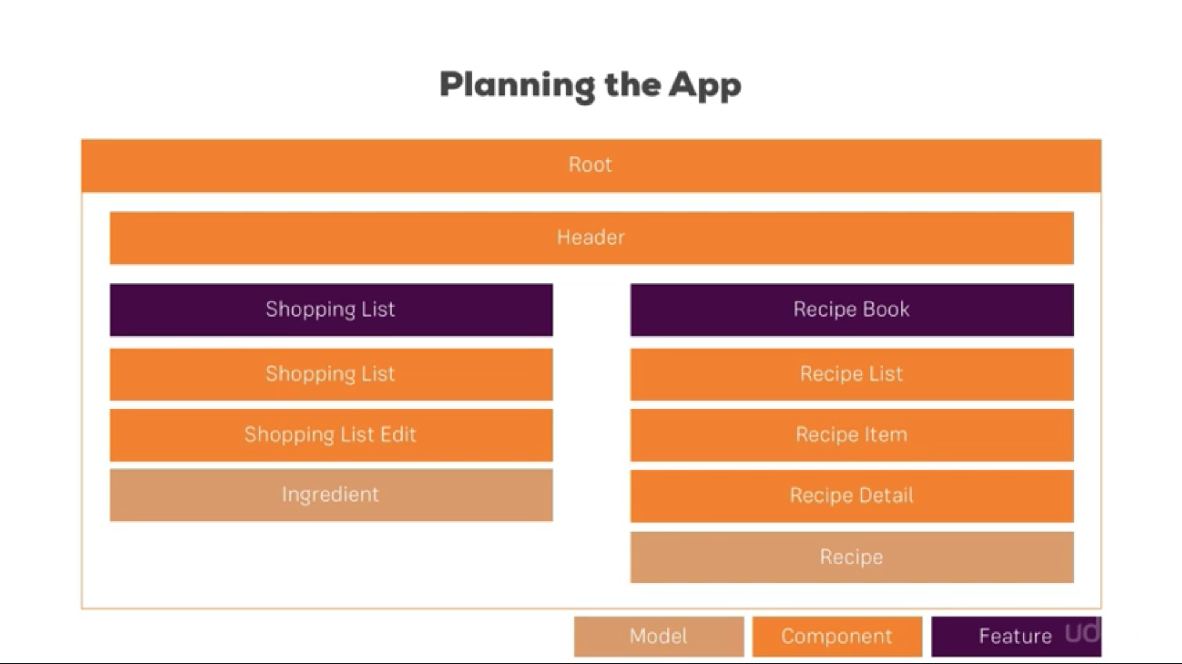

**Installing Bootstrap Correctly**

In the next lecture, we set up the course project. For that, we'll install the Bootstrap CSS Framework.

In this course, we use version 3 of the framework, install it via npm install --save bootstrap@3  => The @3  is important!

Additionally, when using a project created with Angular CLI 6+ (check via ng -v ), you'll have an angular.json  file instead of an .angular-cli.json  file. In that file, you still need to add Bootstrap to the styles[]  array as shown in the next video, but the path should be node_modules/bootstrap/dist/css/bootstrap.min.css , **NOT** ../node_modules/bootstrap/dist/css/bootstrap.min.css . The leading ../  must not be included.

Also see this lecture - I do show the complete setup process there: <https://www.udemy.com/the-complete-guide-to-angular-2/learn/v4/t/lecture/6655614/>

If you're facing any problems, please have a look at this very thorough thread by Jost: <https://www.udemy.com/course/the-complete-guide-to-angular-2/learn/lecture/17862130#questions/10444944>

**To check the Angular version**

ng version

To install latest bootstrap

npm install – save bootstrap

**FYI**

**How to update angular version Verry IMP**

<https://www.genuitec.com/docs/web-apps/modern-web/angular-version/>

<https://update.angular.io/#8.2:9.0>

Run ng update @angular/core@9 @angular/cli@9 which should bring you to version 9 of Angular.

Angular 4 has .angular-cli.json file where as Angular 10 has angular.json

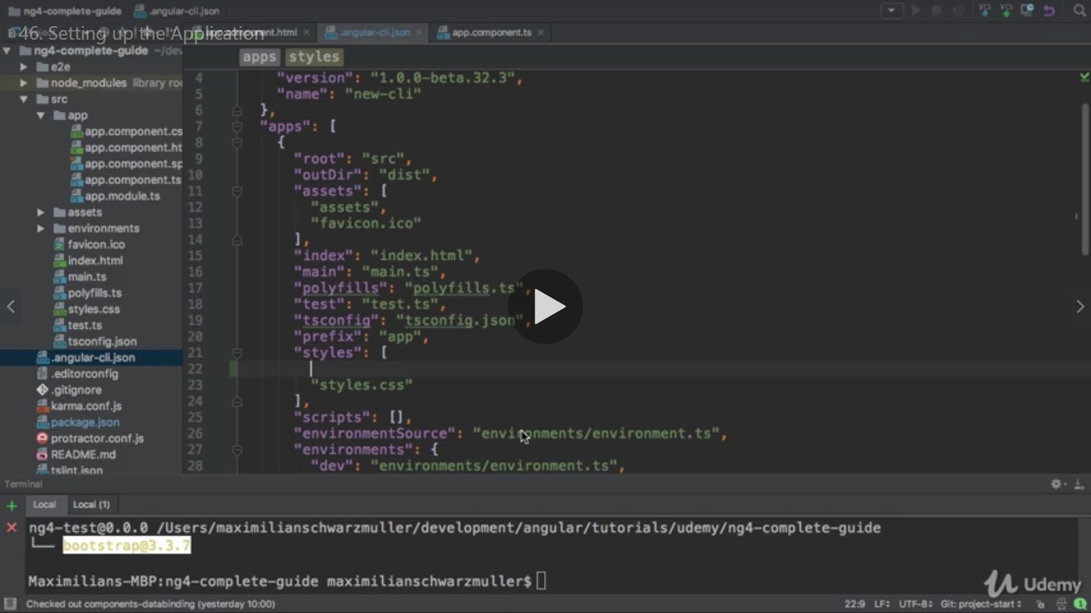

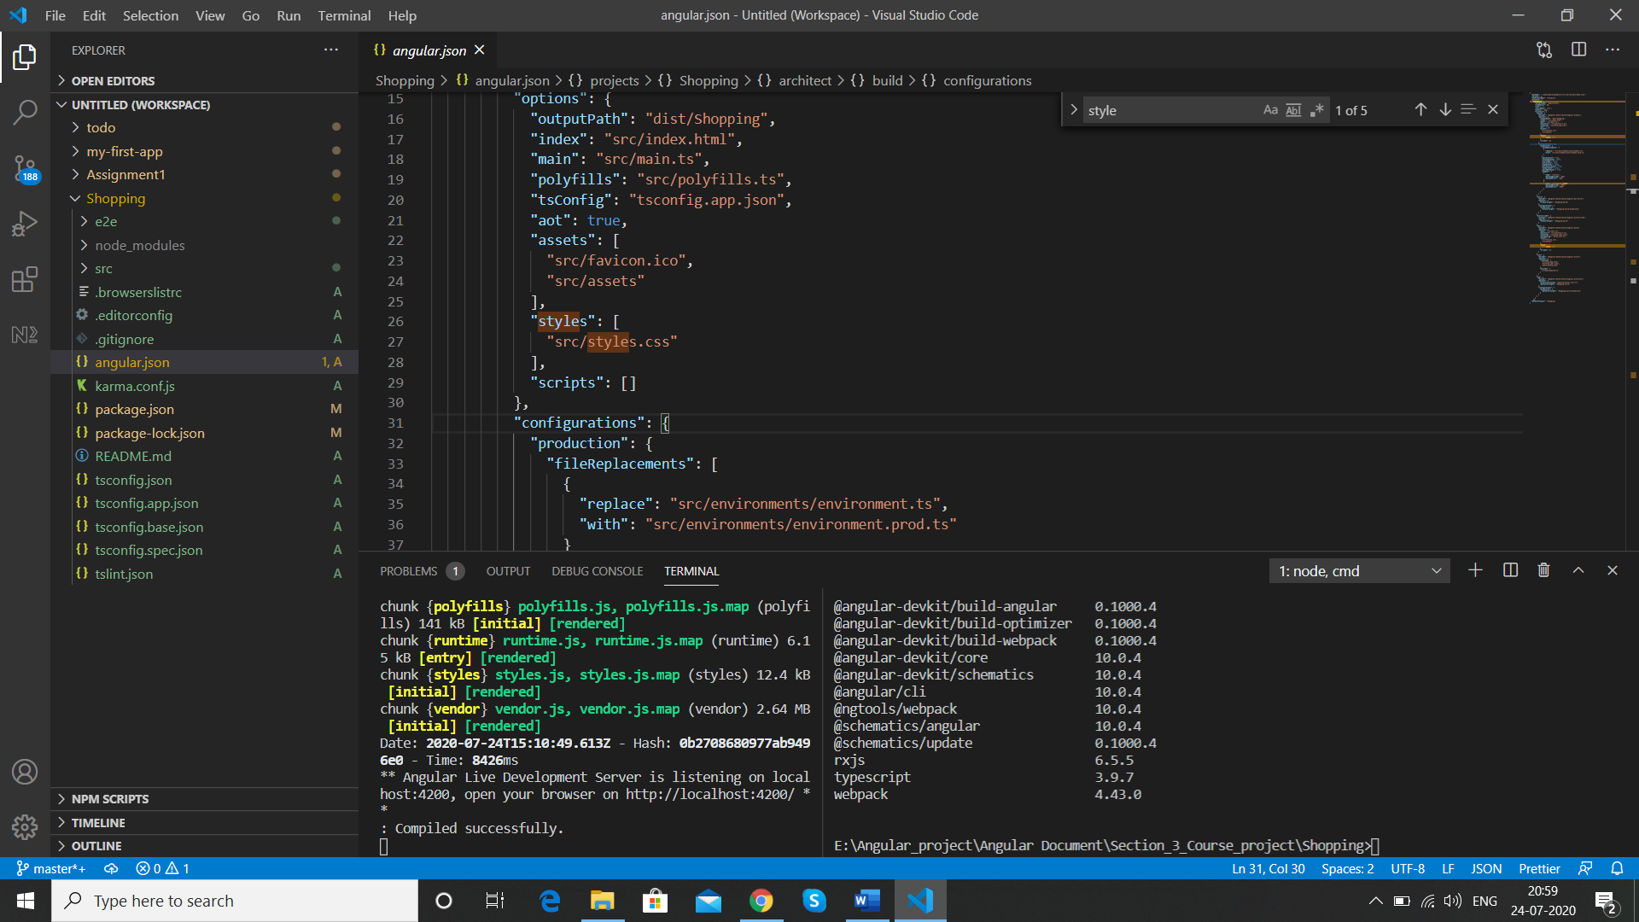

We set bootstrap here so that it takes from the index.html so we use ../ directory

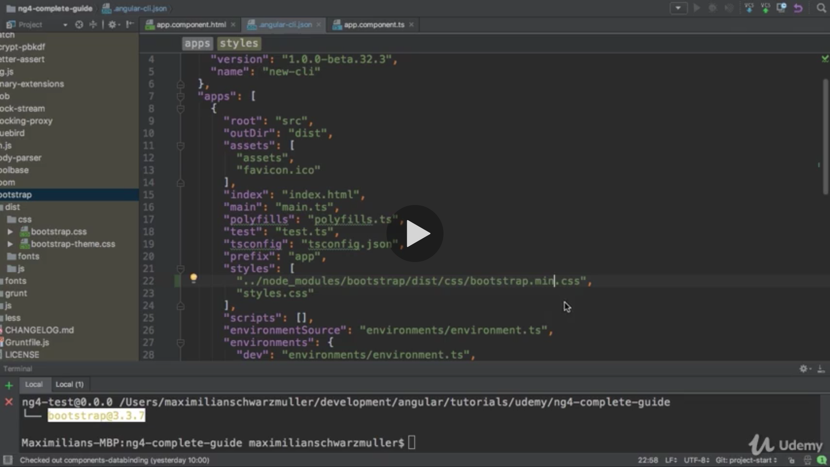

We can create new component without having spec file

Ng g c “component” - -skipTest true

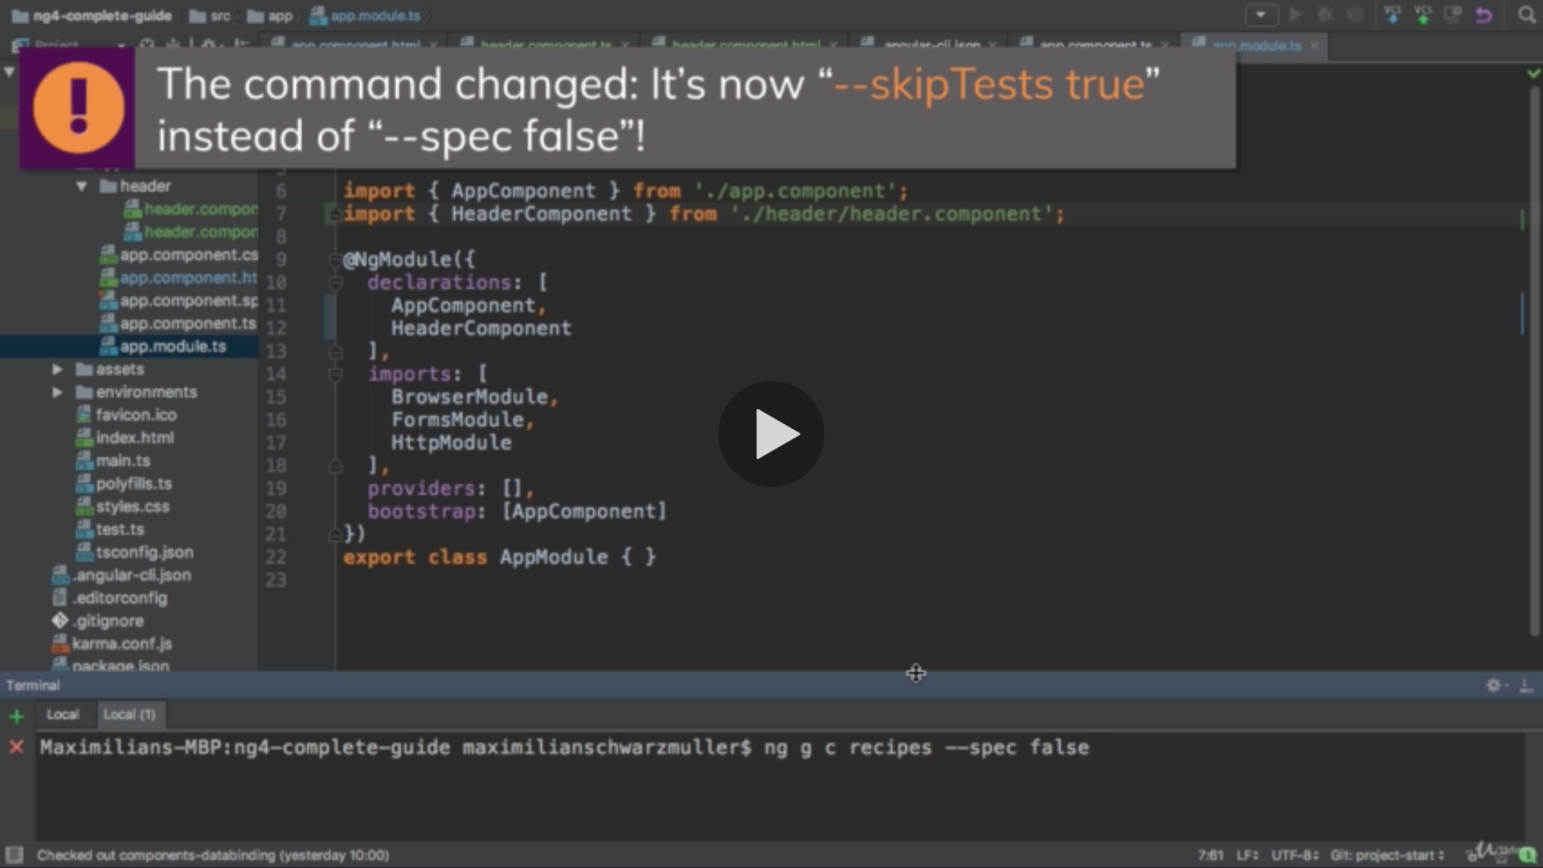

E:\Angular_project\Angular Document\Section_3_Course_project\Shopping>ng g c recipes --skipTests true

CREATE src/app/recipes/recipes.component.html (22 bytes)

CREATE src/app/recipes/recipes.component.ts (279 bytes)

CREATE src/app/recipes/recipes.component.css (0 bytes)

UPDATE src/app/app.module.ts (559 bytes)

Components created

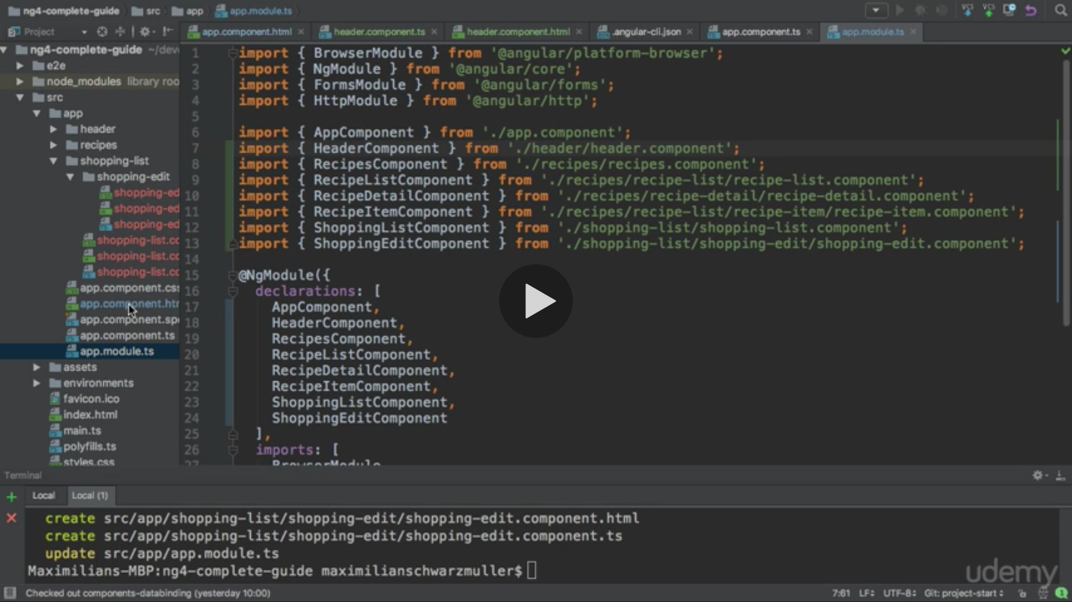

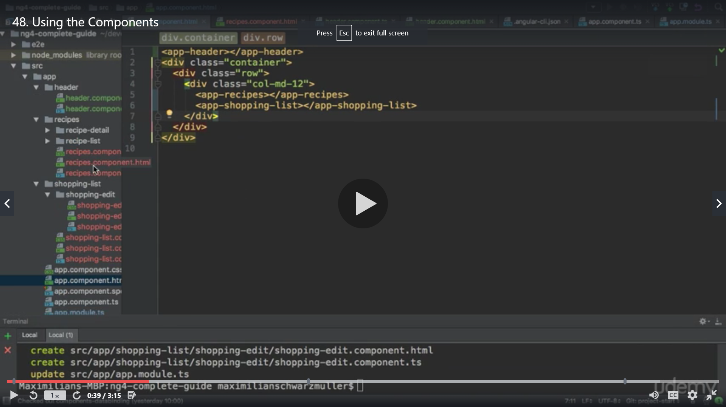

After adding all components and selectors in appropriate component

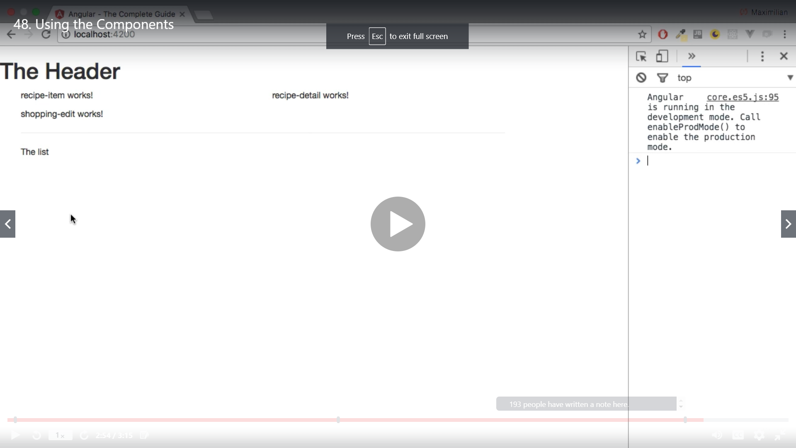

**Alternative Non-Collapsable Navigation Bar**

The way we added it, the Navbar will collapse on smaller screens. Since we didn't implement a Hamburger menu, that means that there's no way of accessing our links on smaller screens.

You can either add such a menu on your own (see below), or you replace collapse navbar-collapse  with just navbar-default.

Adding a Hamburger Menu:

Alternatively, if you want to make the navigation bar responsive, please replace these lines in header.component.html:

1. <div class="navbar-header">
2. <a routerLink="/" class="navbar-brand">Recipe Book</a>
3. </div>
4. <div class="collapse navbar-collapse">

with these lines:

1. <div class="navbar-header">
2. <button type="button" class="navbar-toggle" (click)="collapsed = !collapsed">
3. <span class="icon-bar" *ngFor="let iconBar of [1, 2, 3]"></span>
4. </button>
5. <a routerLink="/" class="navbar-brand">Recipe Book</a>
6. </div>
7. <div class="navbar-collapse" [class.collapse]="collapsed" (window:resize)="collapsed = true">

and add this line to header.component.ts:

1. collapsed = true;

We add recipe model in recipes folder recipe.model.ts

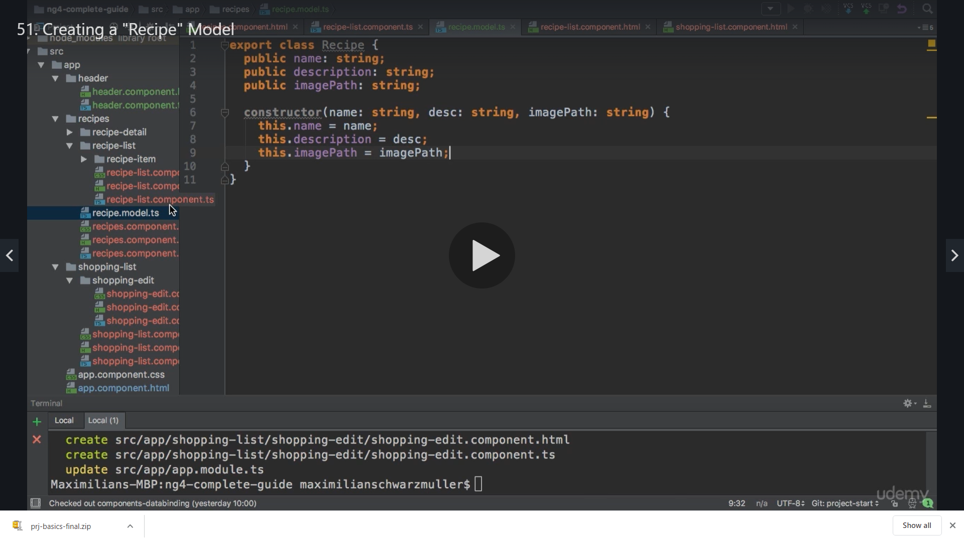

We have recipe list component where we will use the model

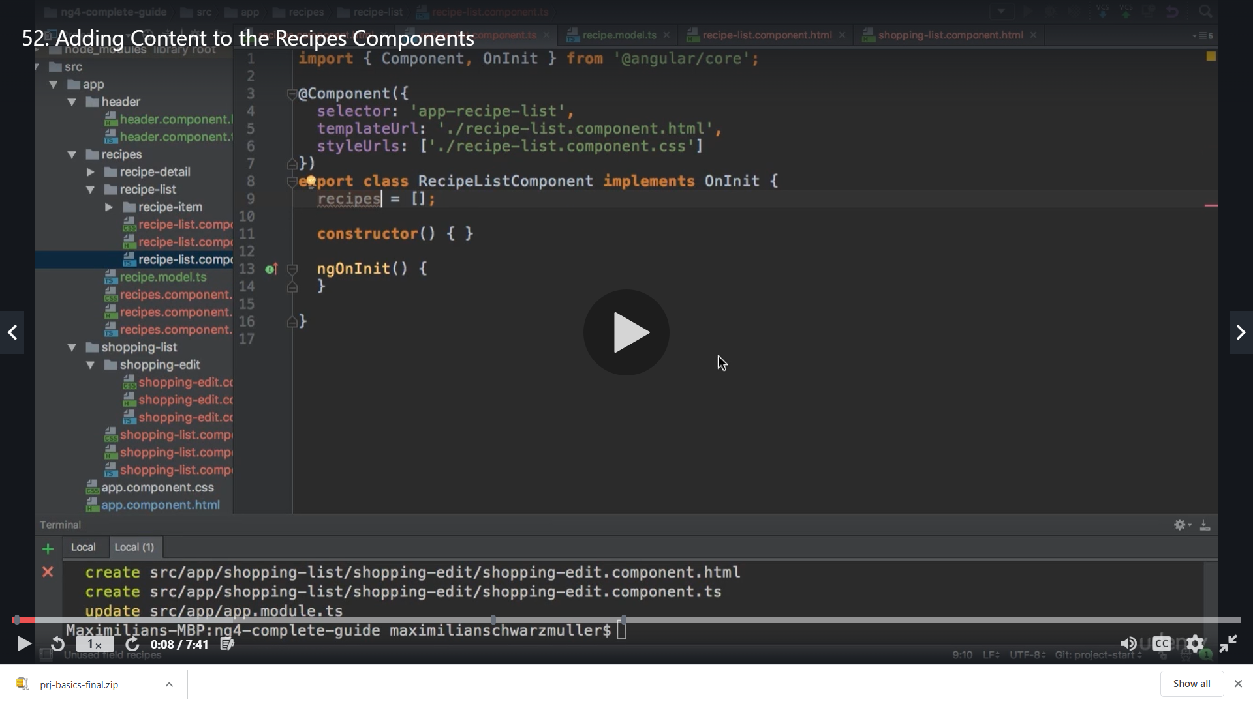

We define a variable recipes and give it a type as Recipe[ ] so that this will contain objects everytime

For image we added the path from internet

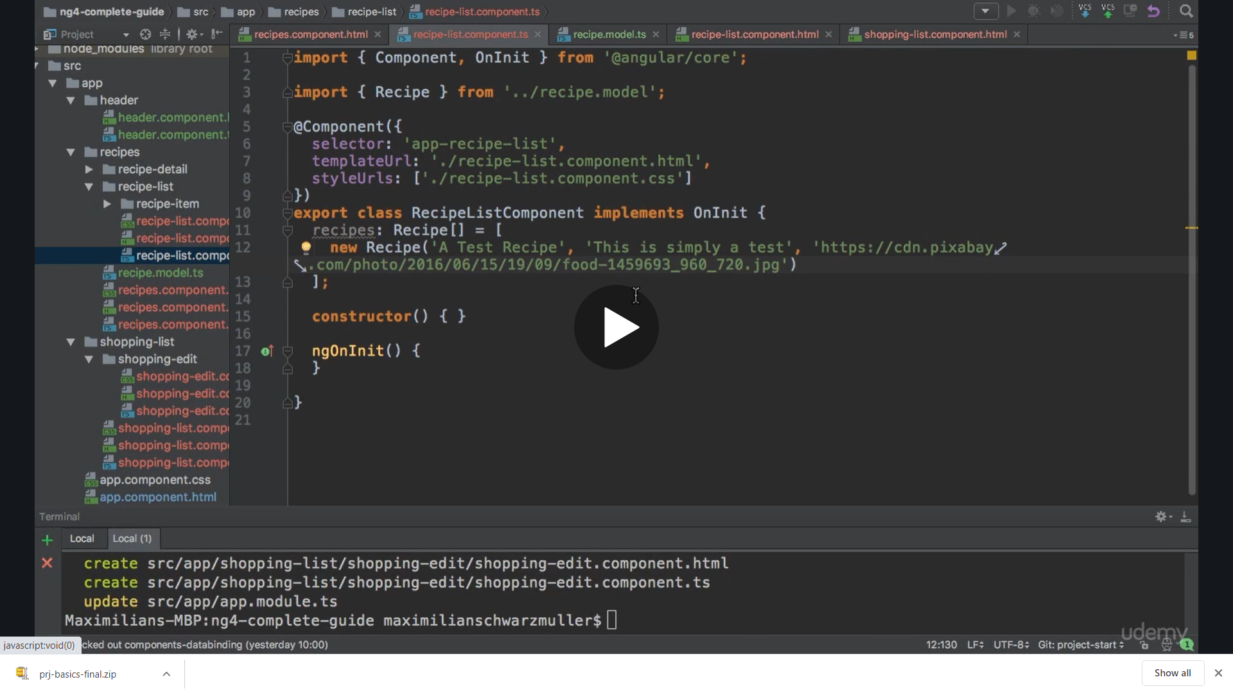

Recepie-list.component.html

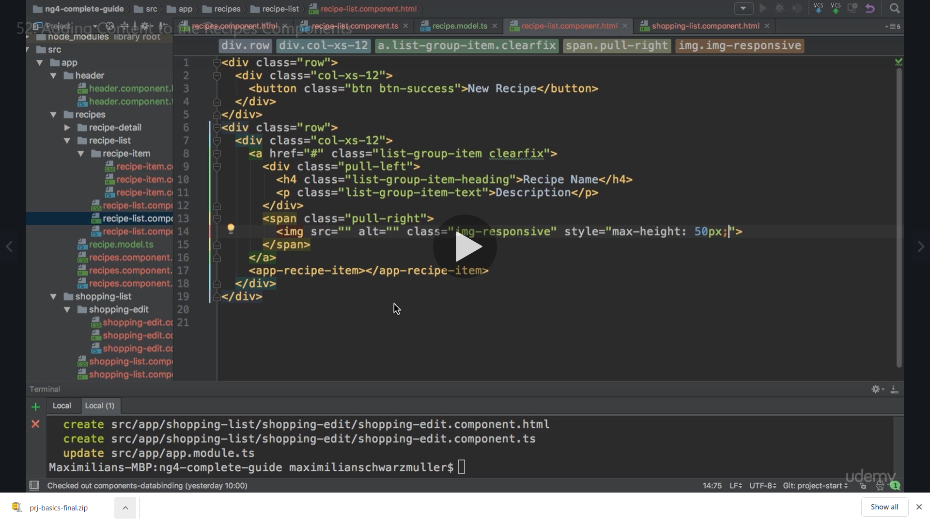

For recipe imagePath we can use property binding as well as string interpolation

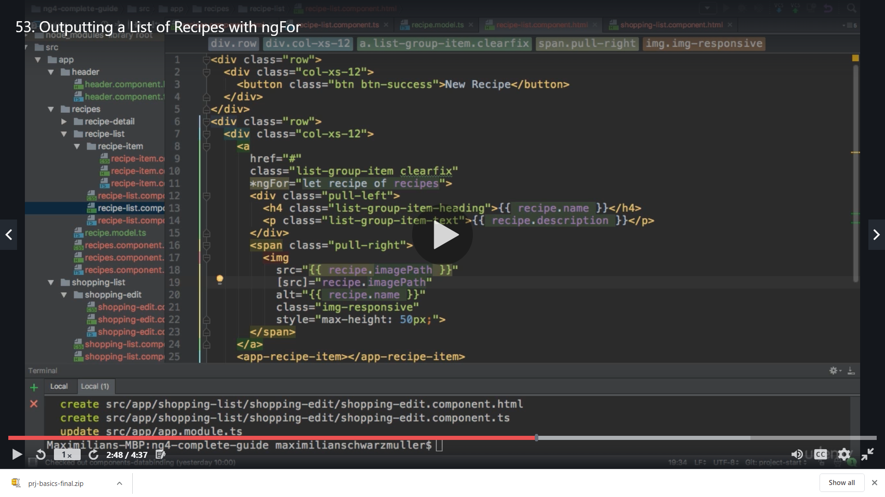

Add more values

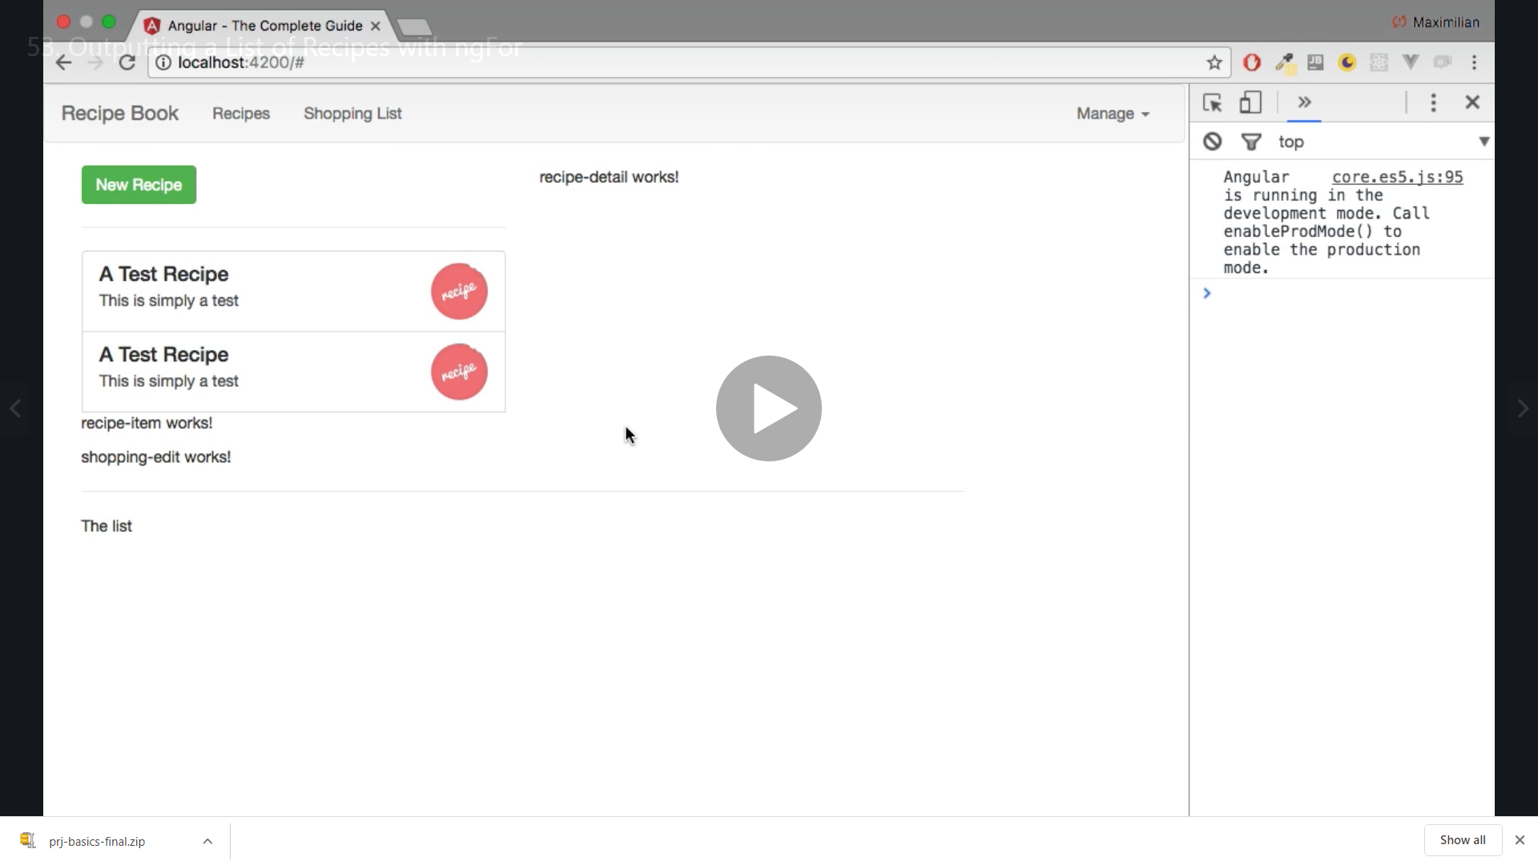

Now recepie detail

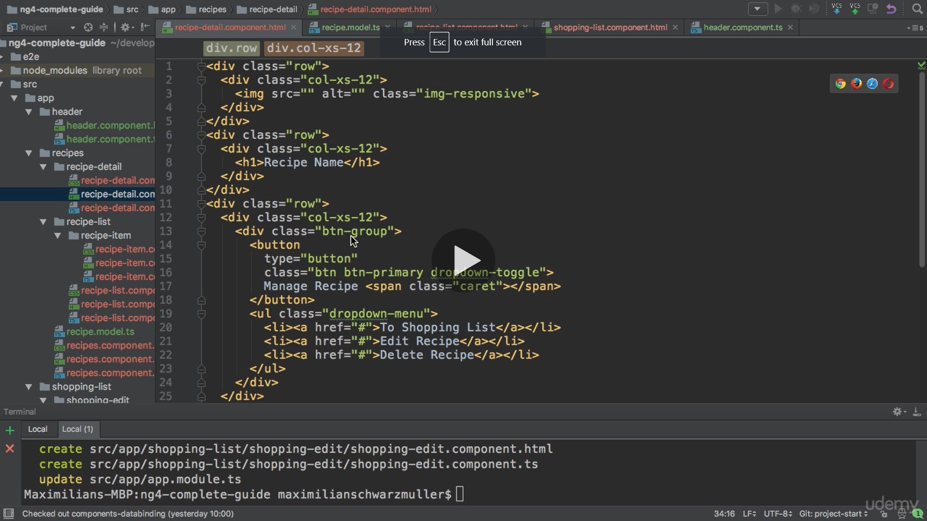

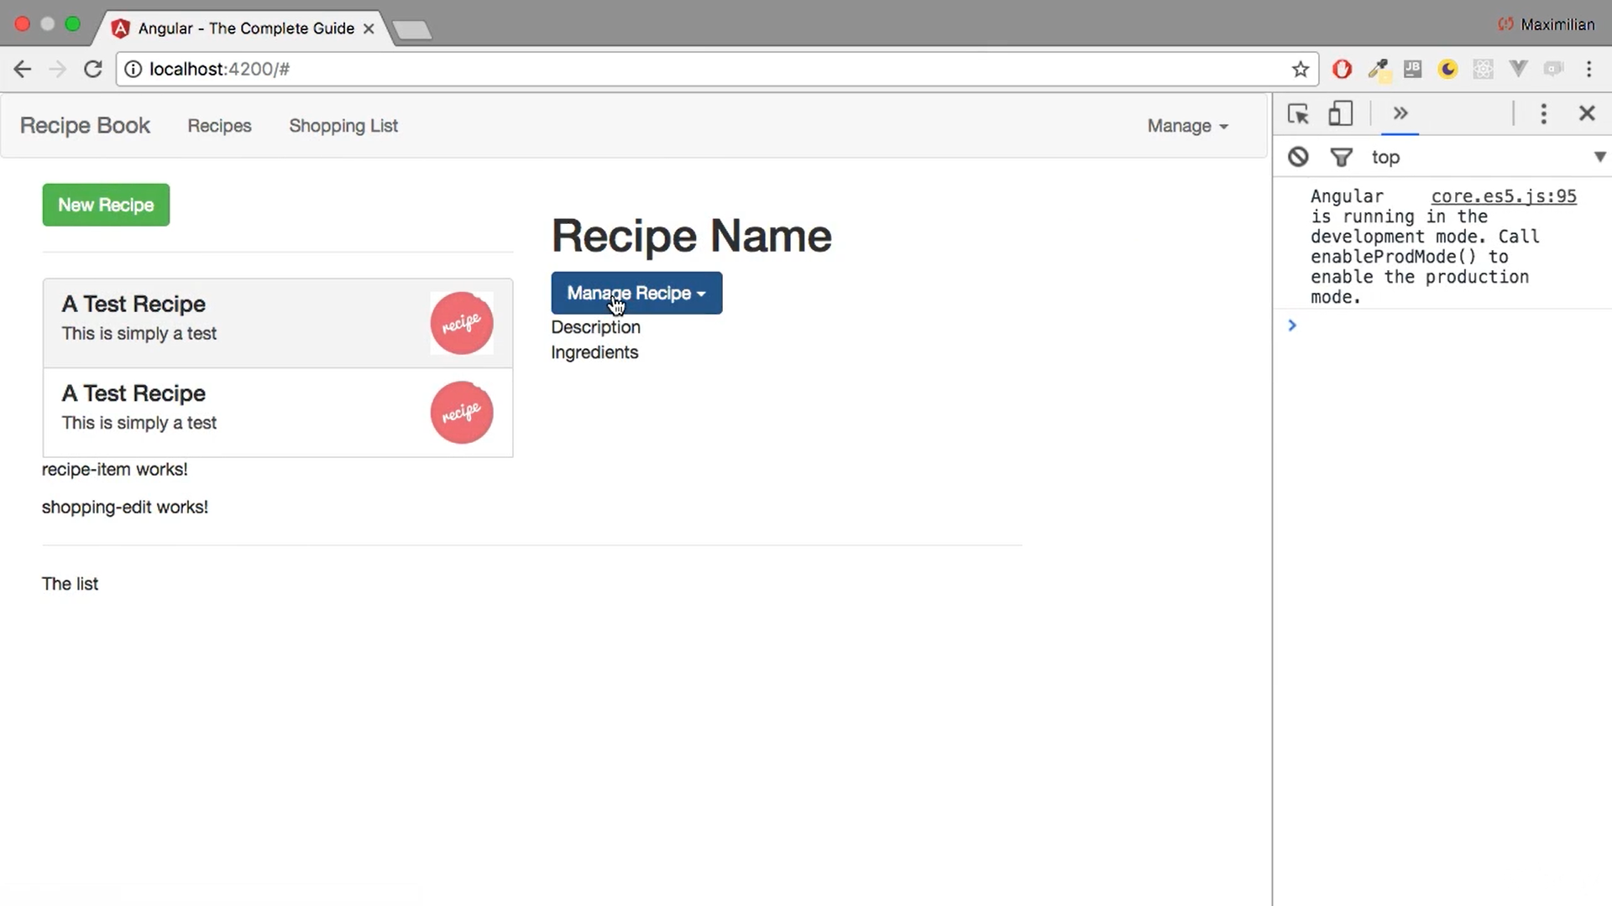

Shopping list component

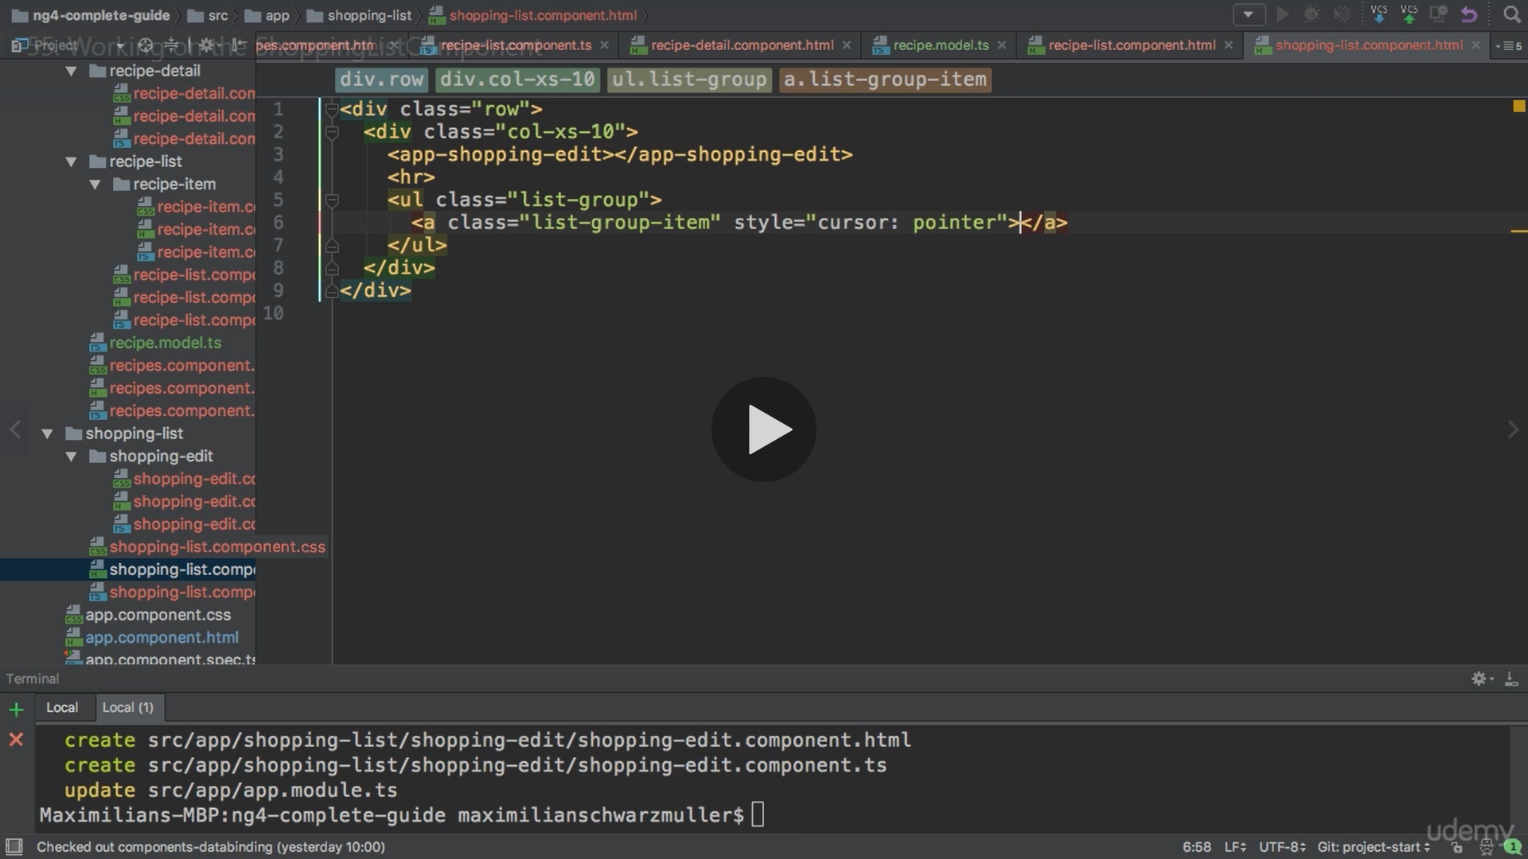

Shopping list component.ts

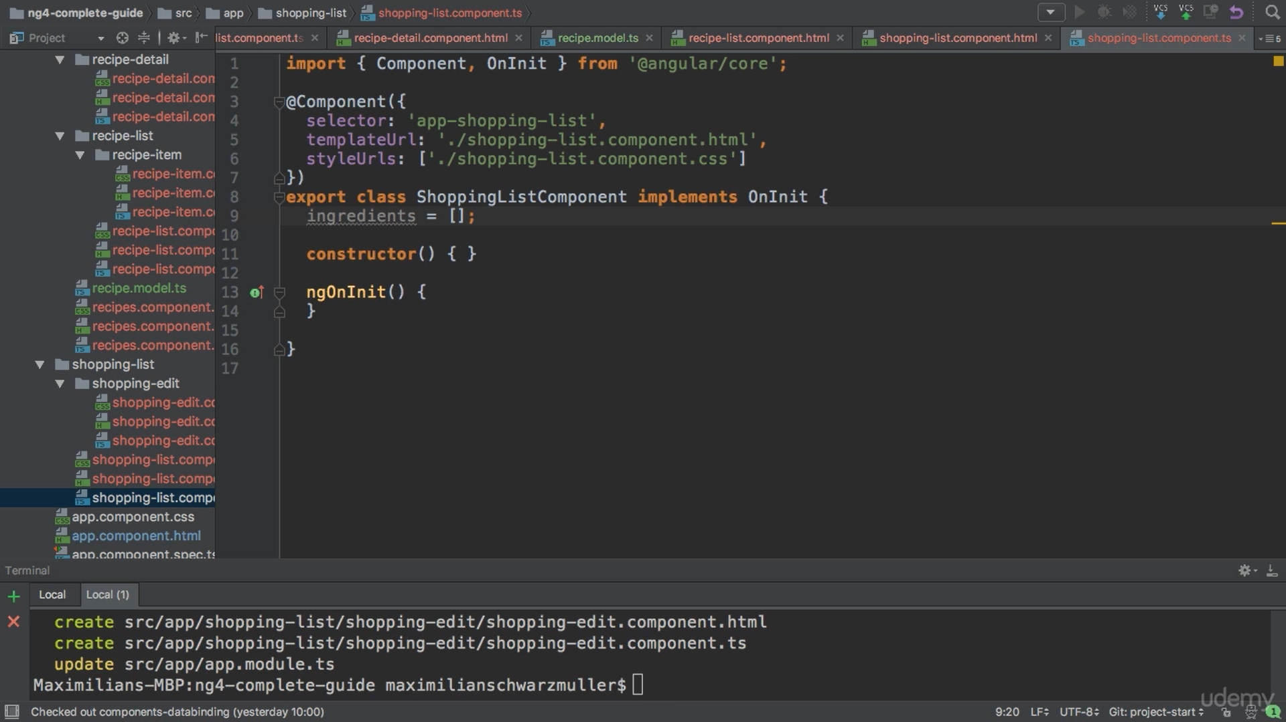

**Sharing Data across components Components interlinking**

We create a folder named shared in app and create ingredient folder which contains ingrediants.module.ts

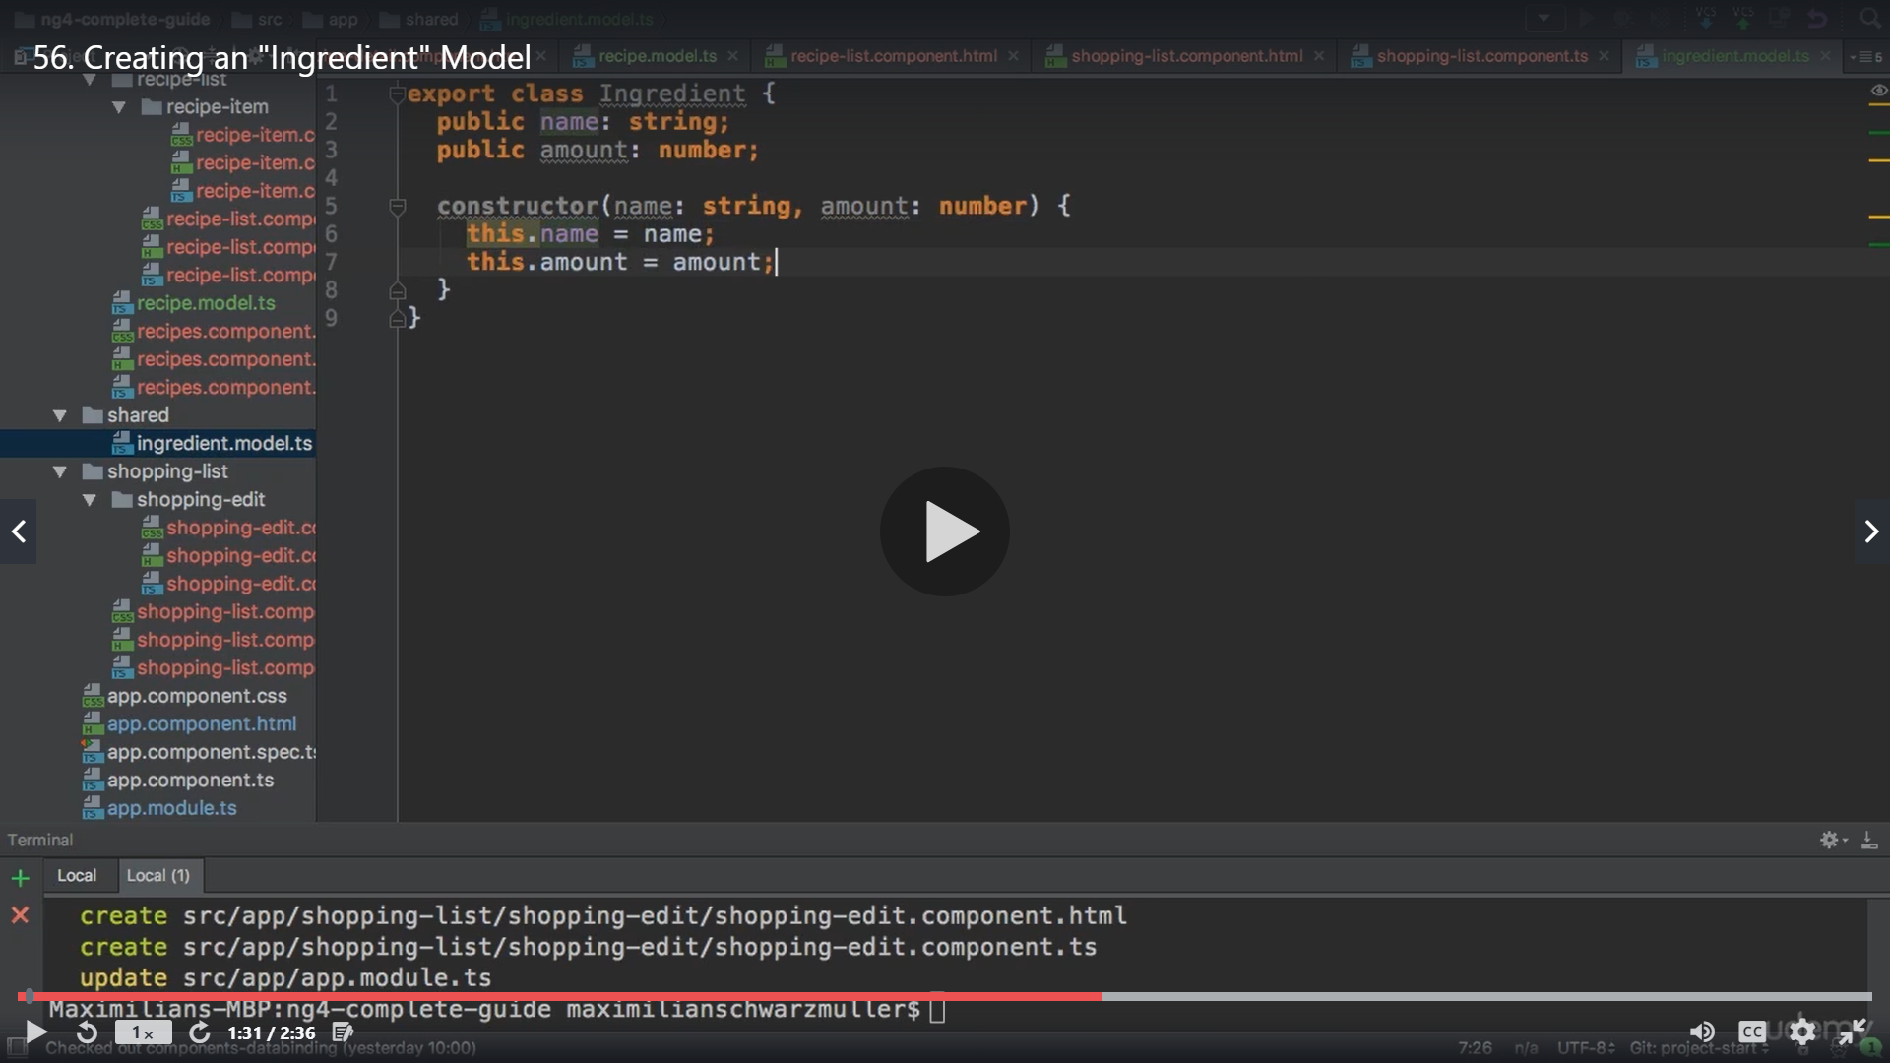

Typescript offers a shortcut we can declare the model as below

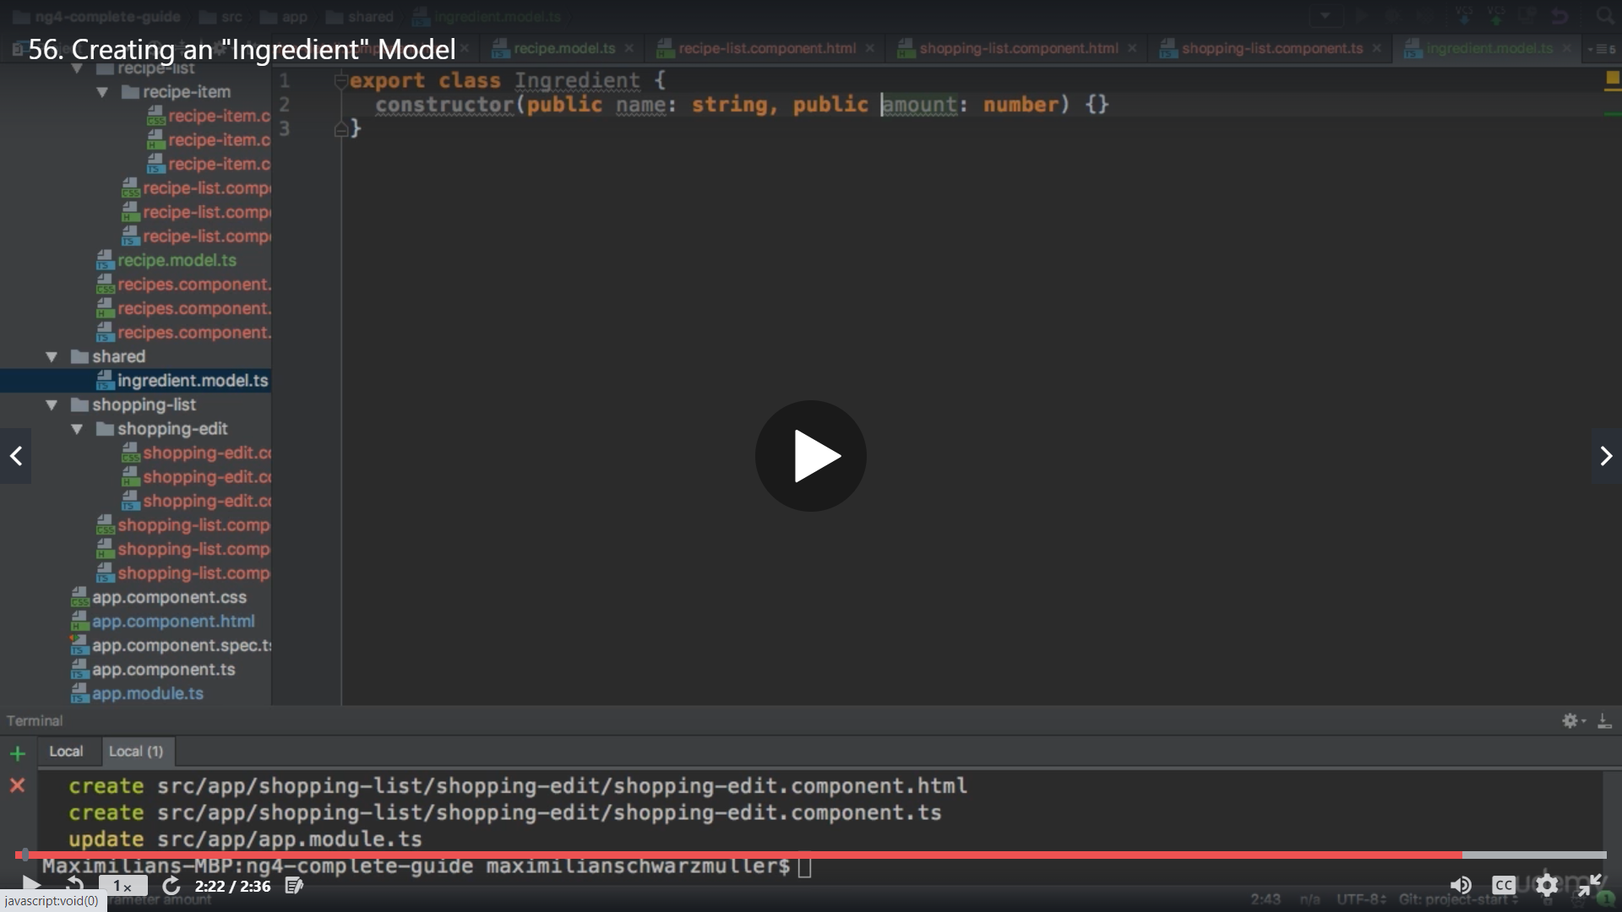

Now we can use the ingrediants in shopping list component

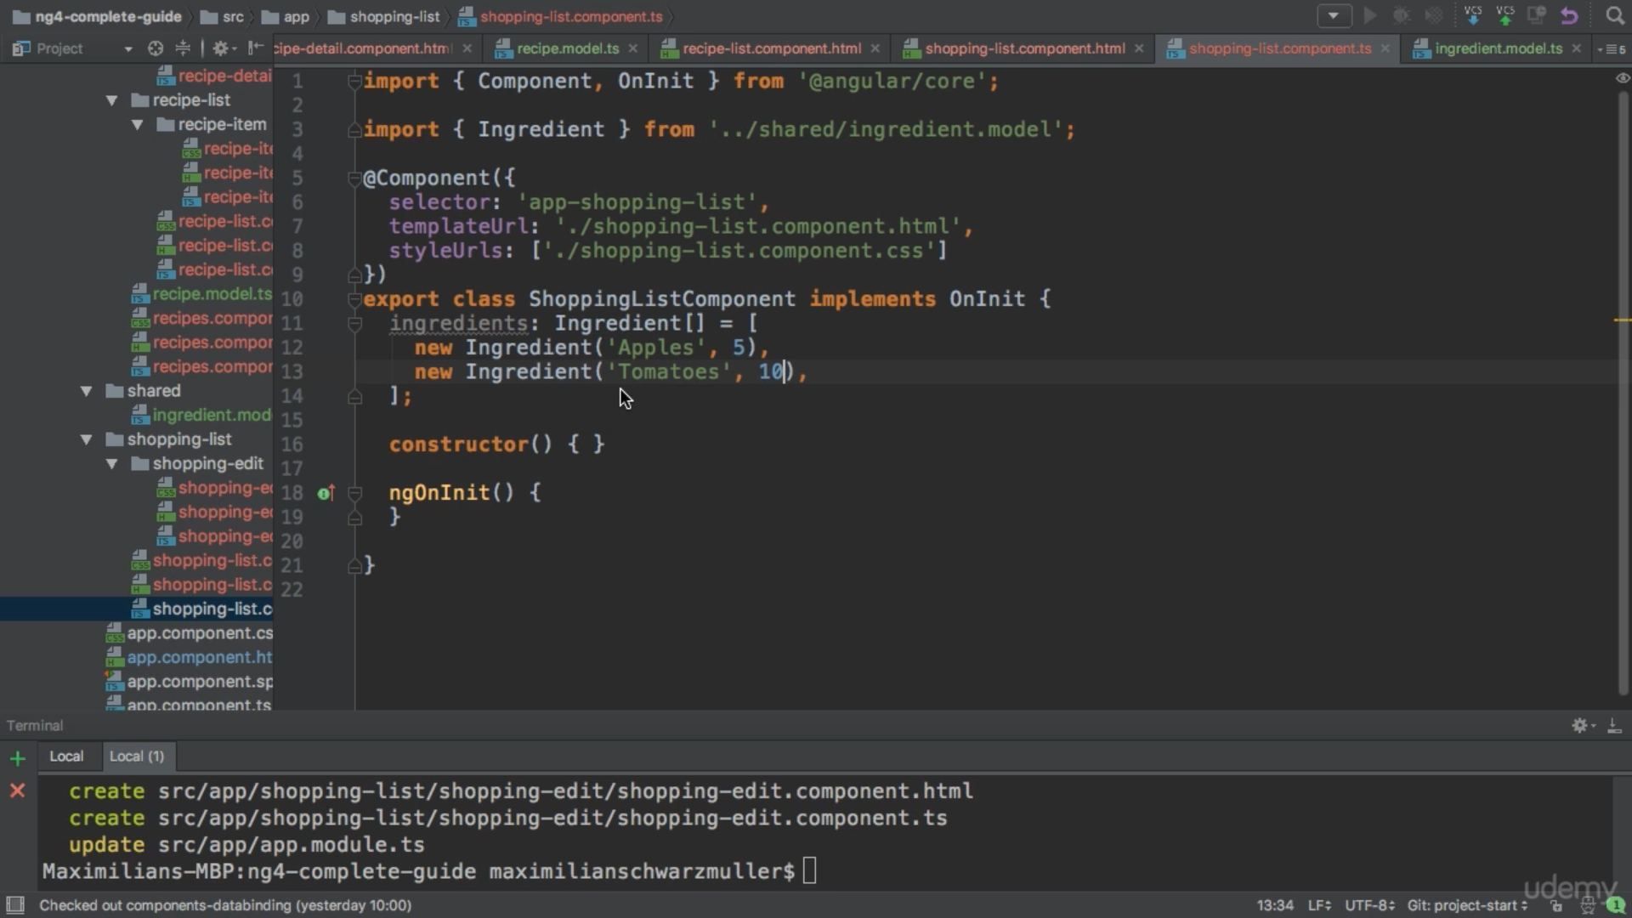

We now populate the values on htmls

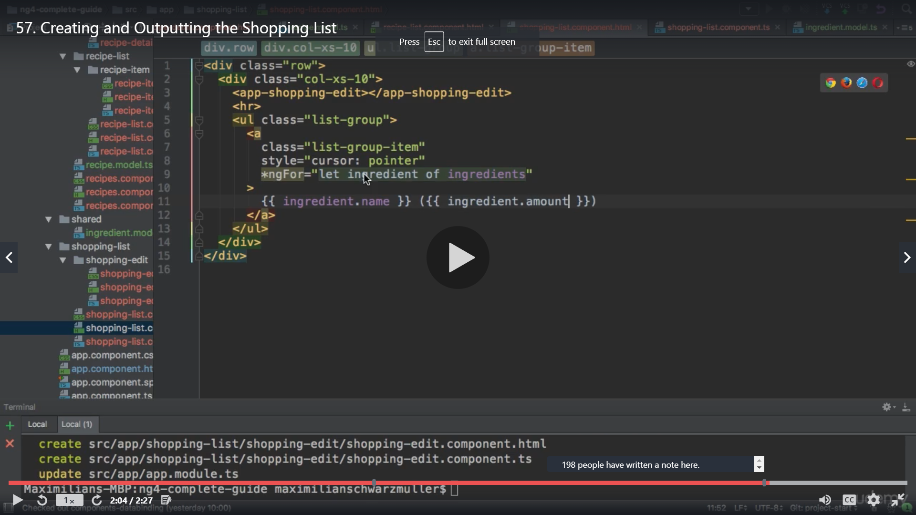

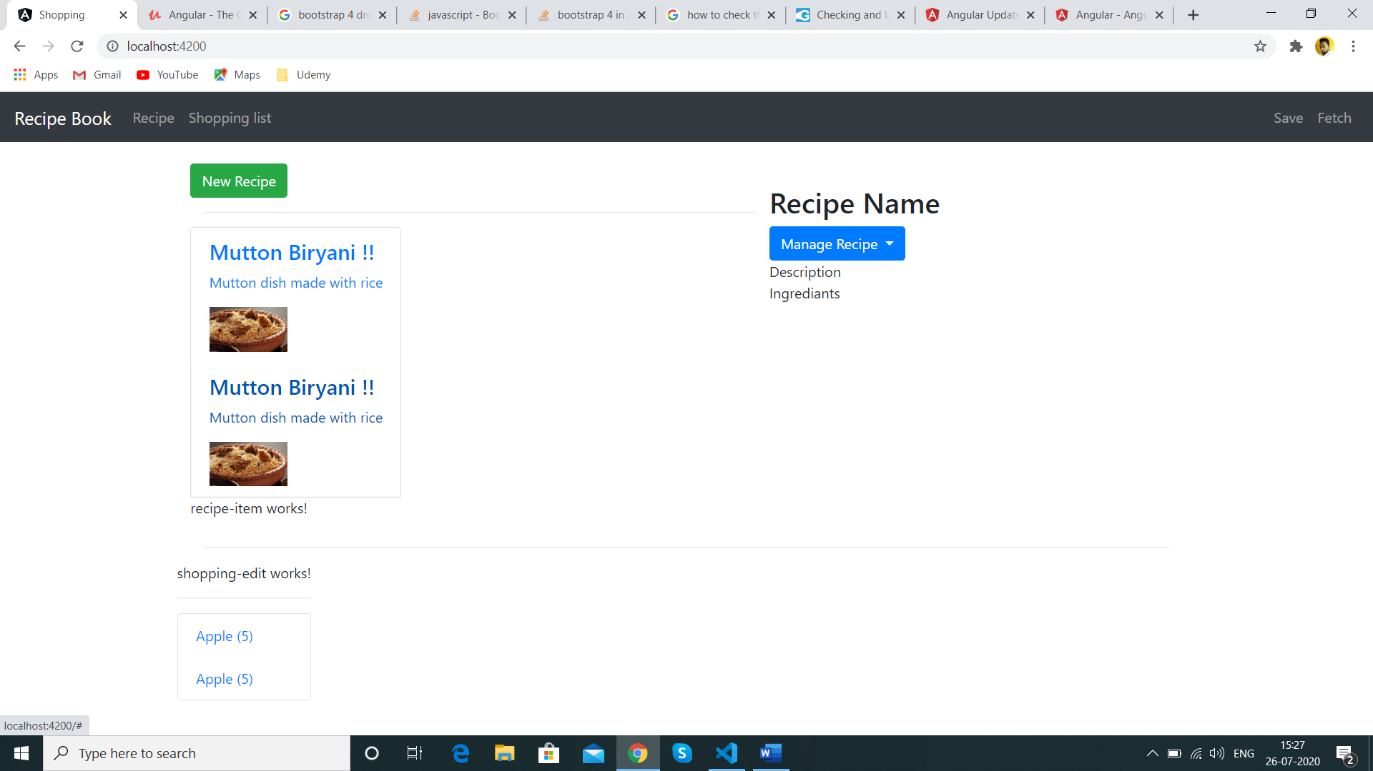

Now Shopping list edit component we have used form here but did not use any event on it

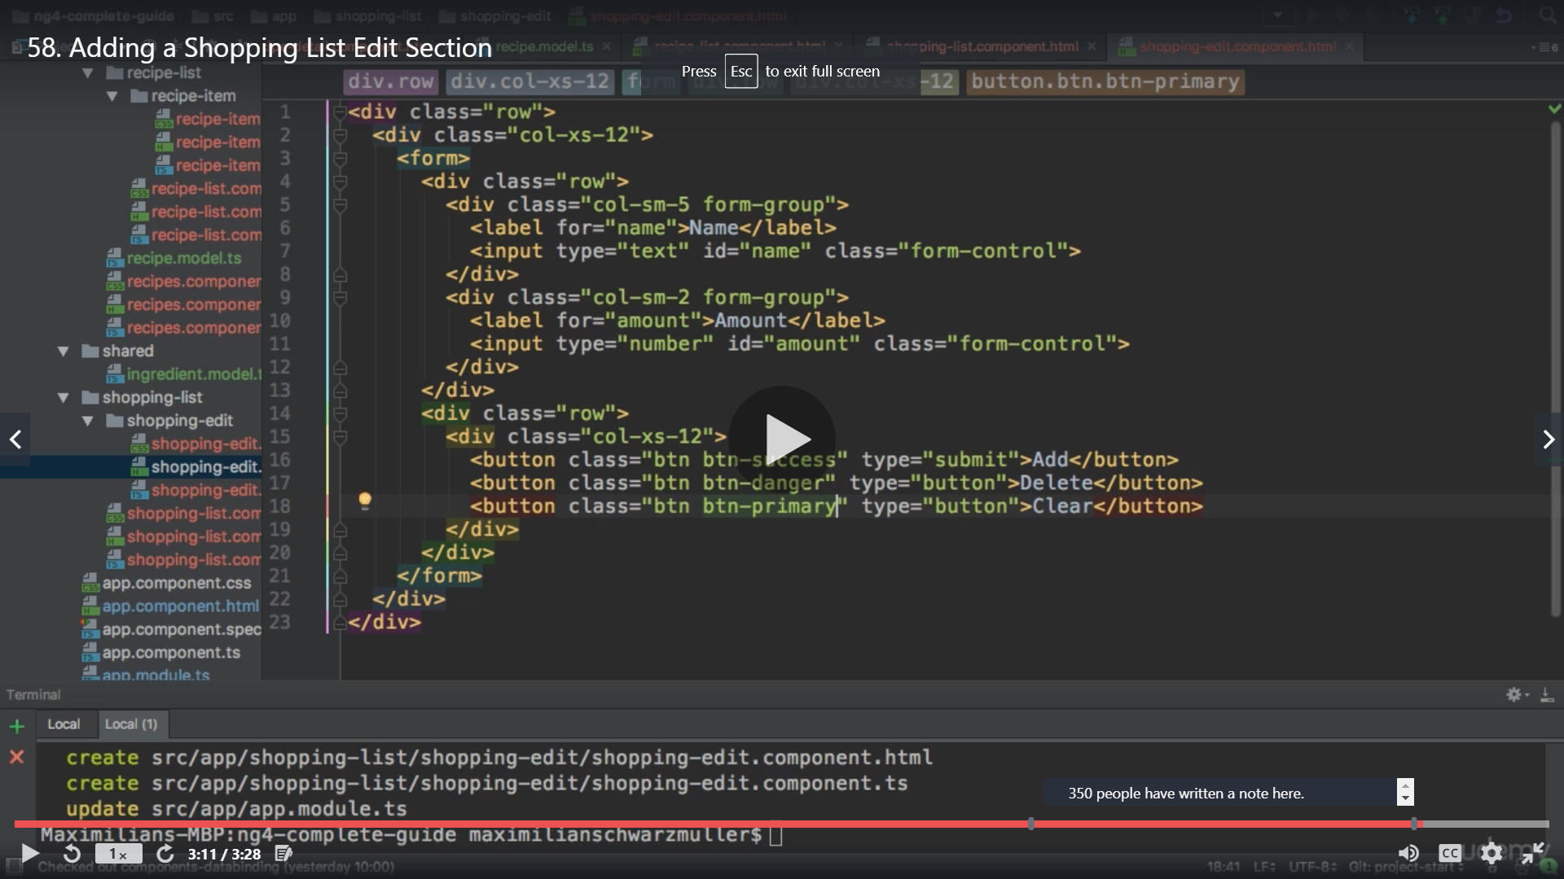

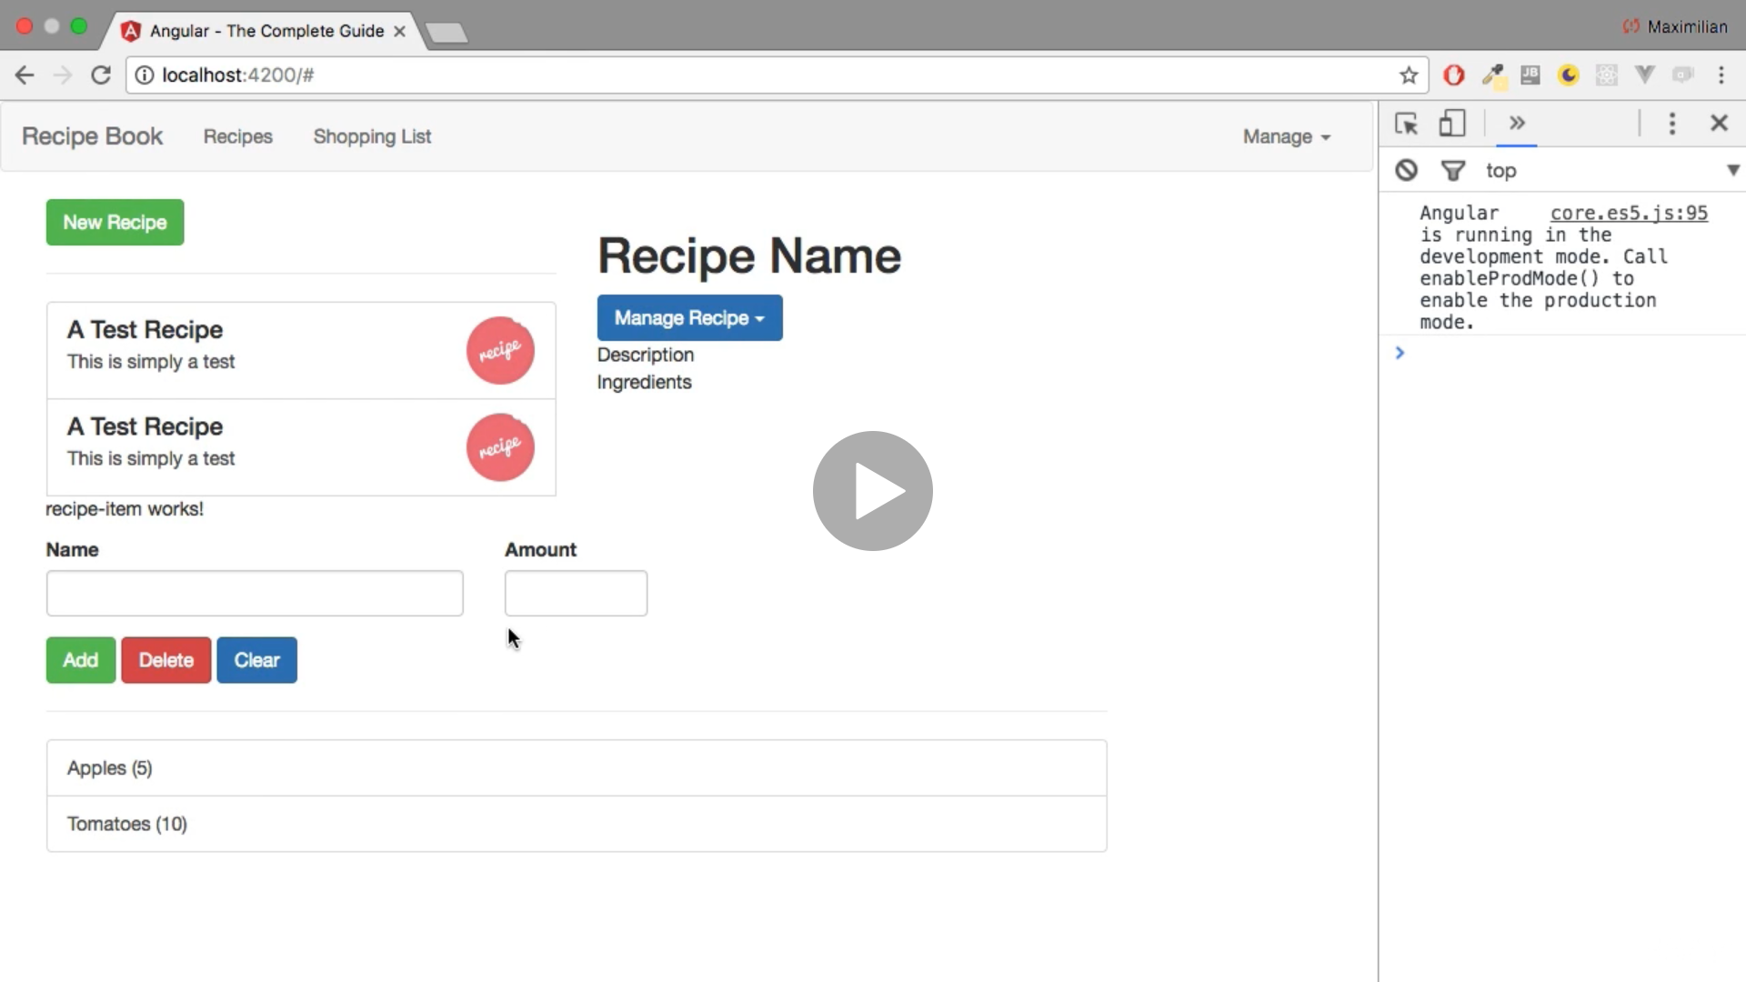

**Debugging /Understanding the Angular error code**

**Property undefined**

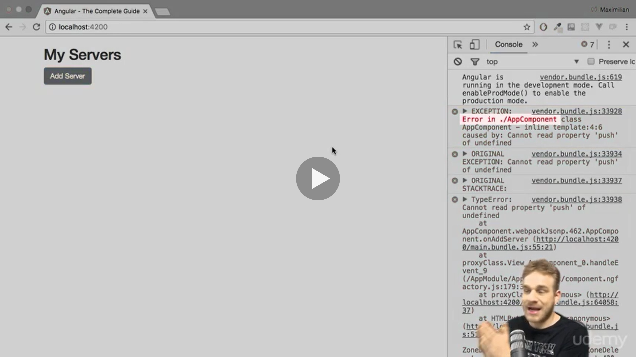

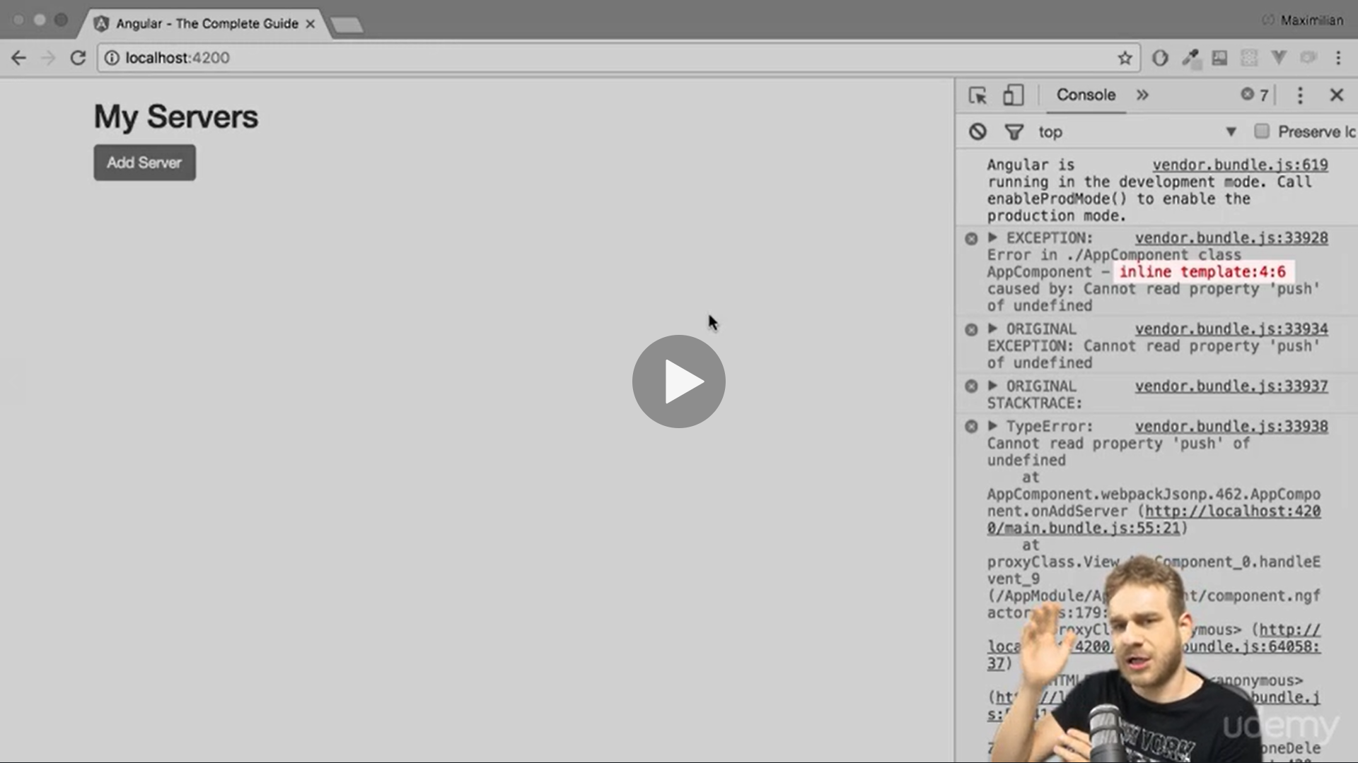

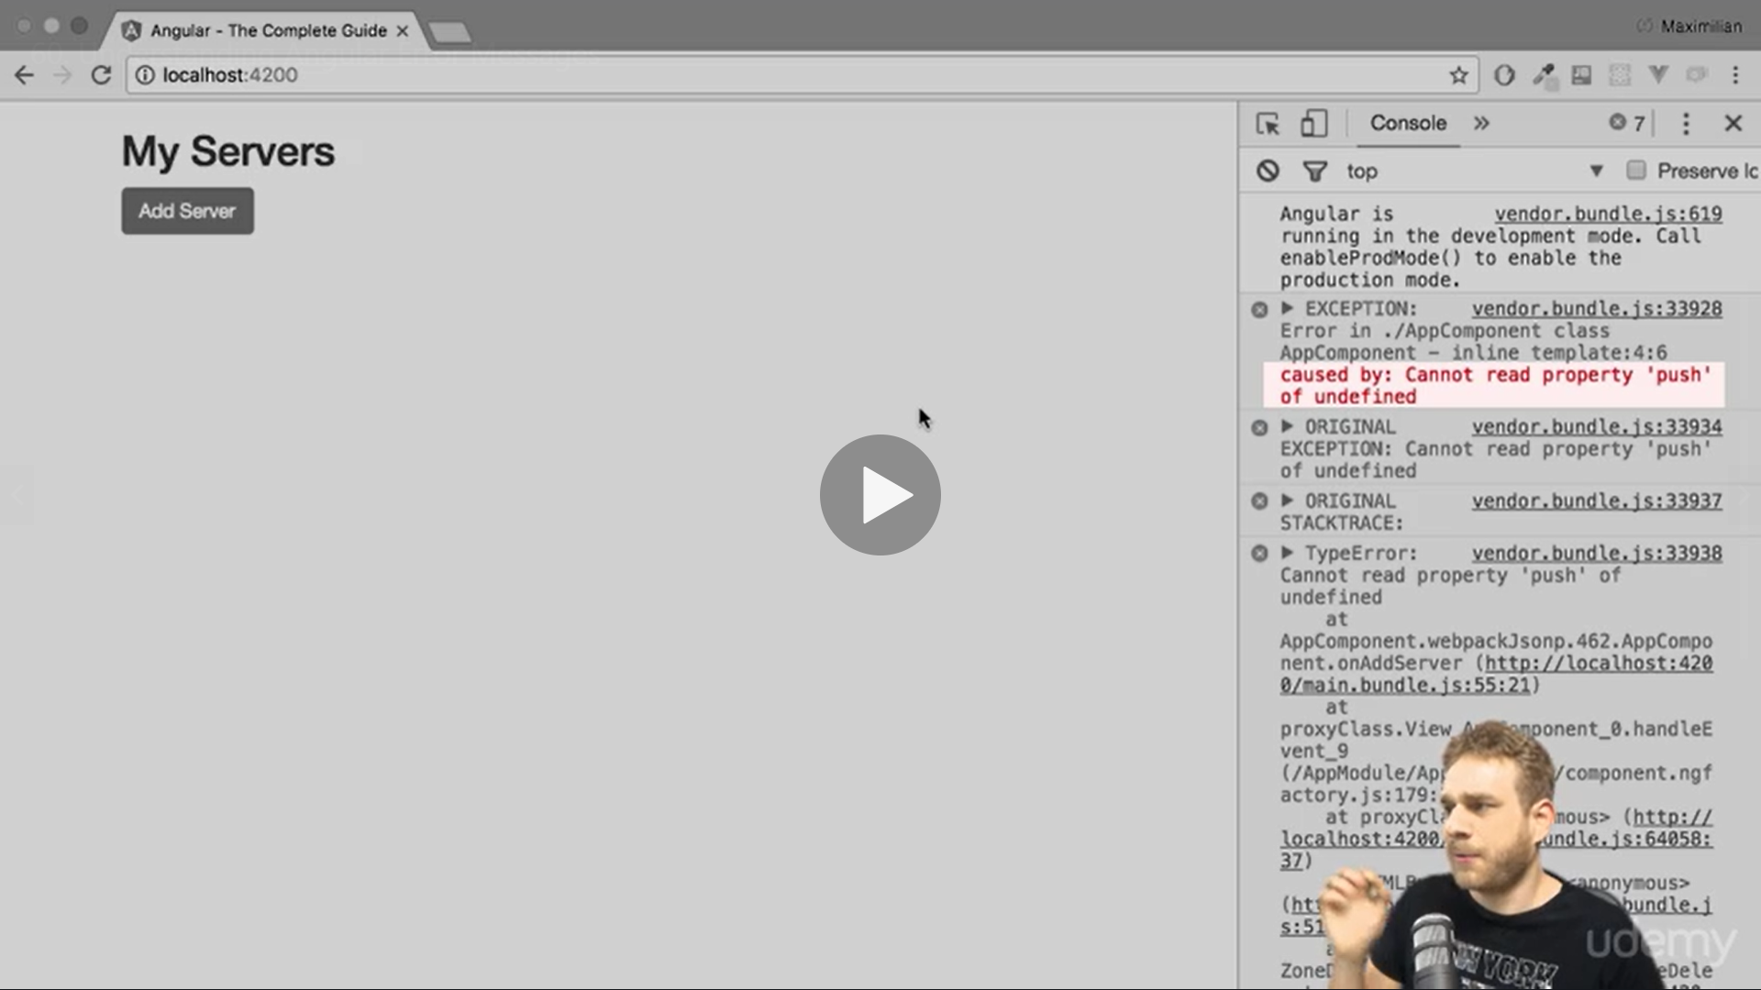

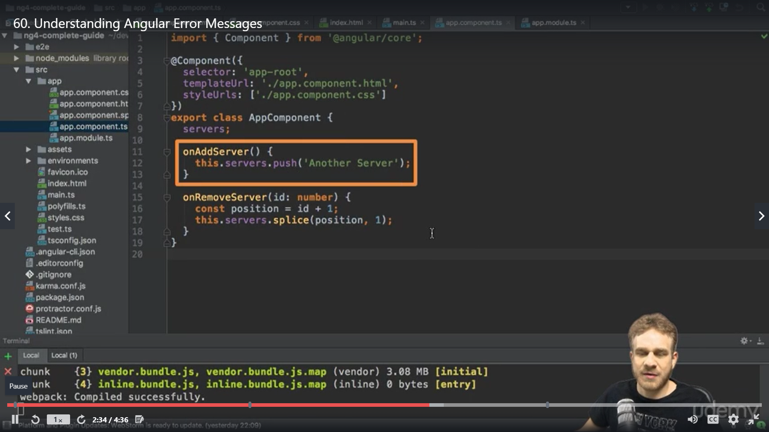

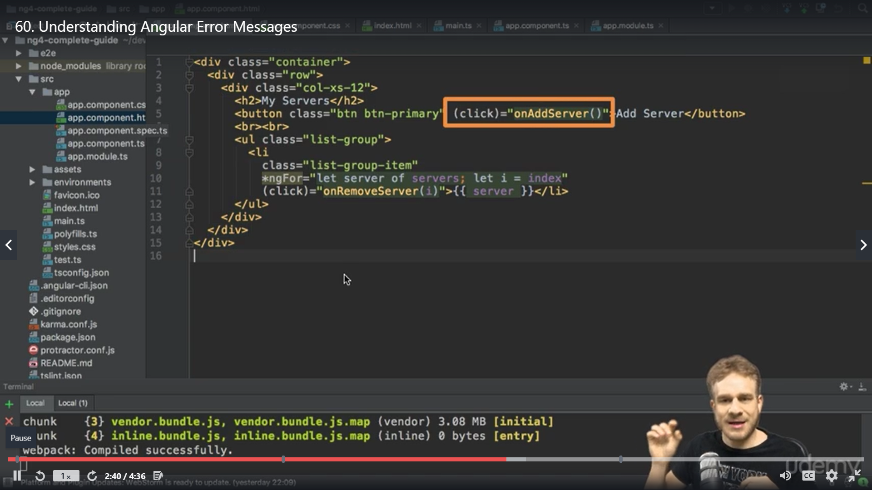

The issue is because we have declared just and not defined we need to initialise it as array

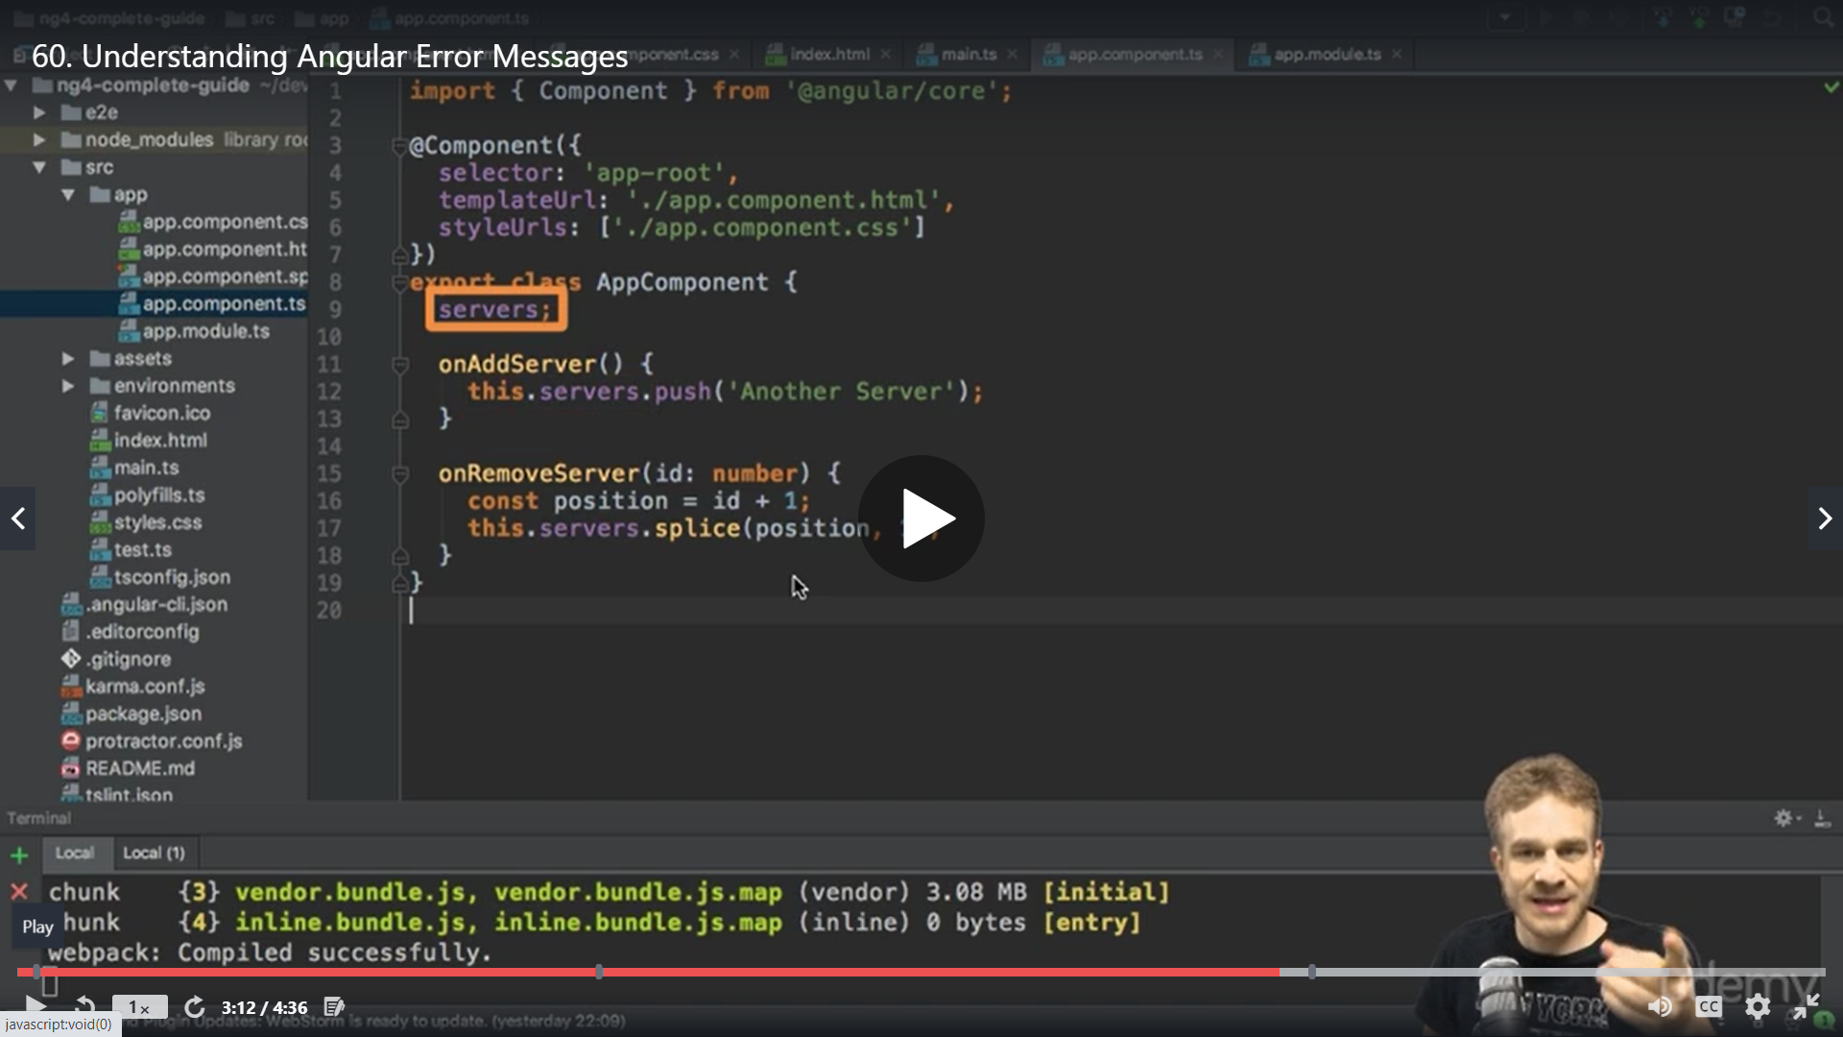

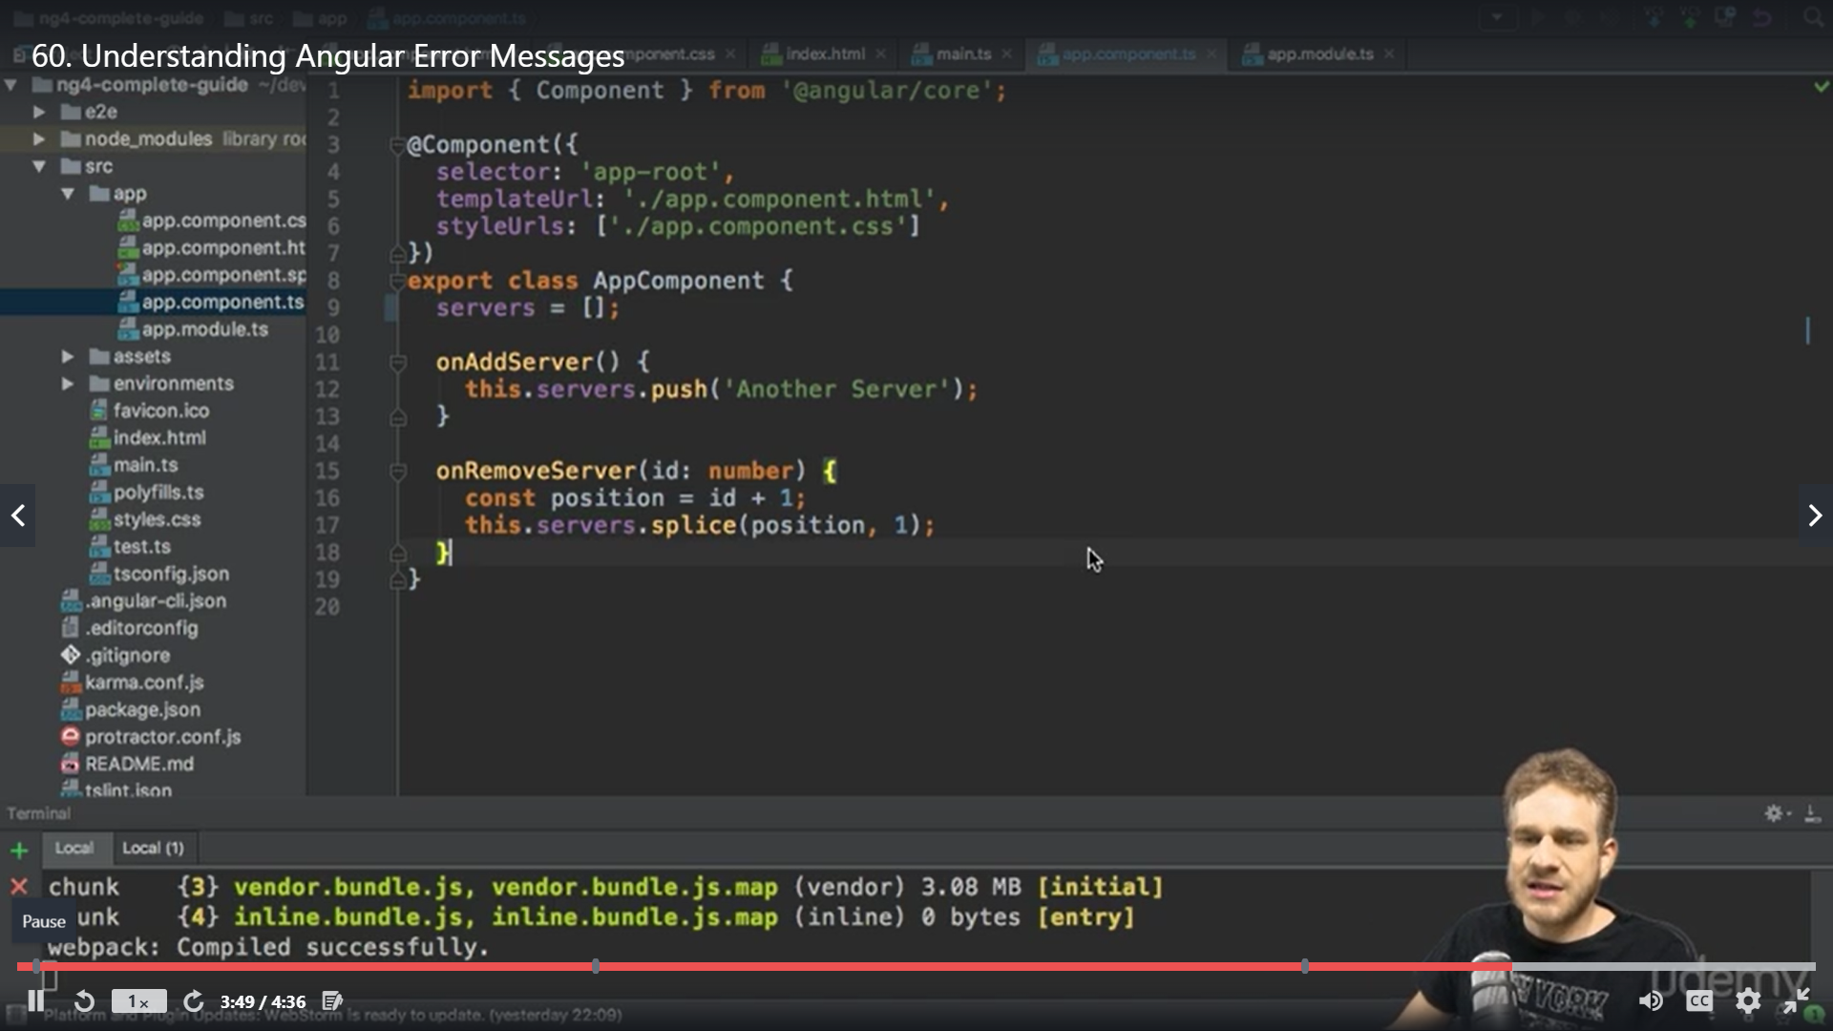

**Scenario is remove server on click on list item not working**

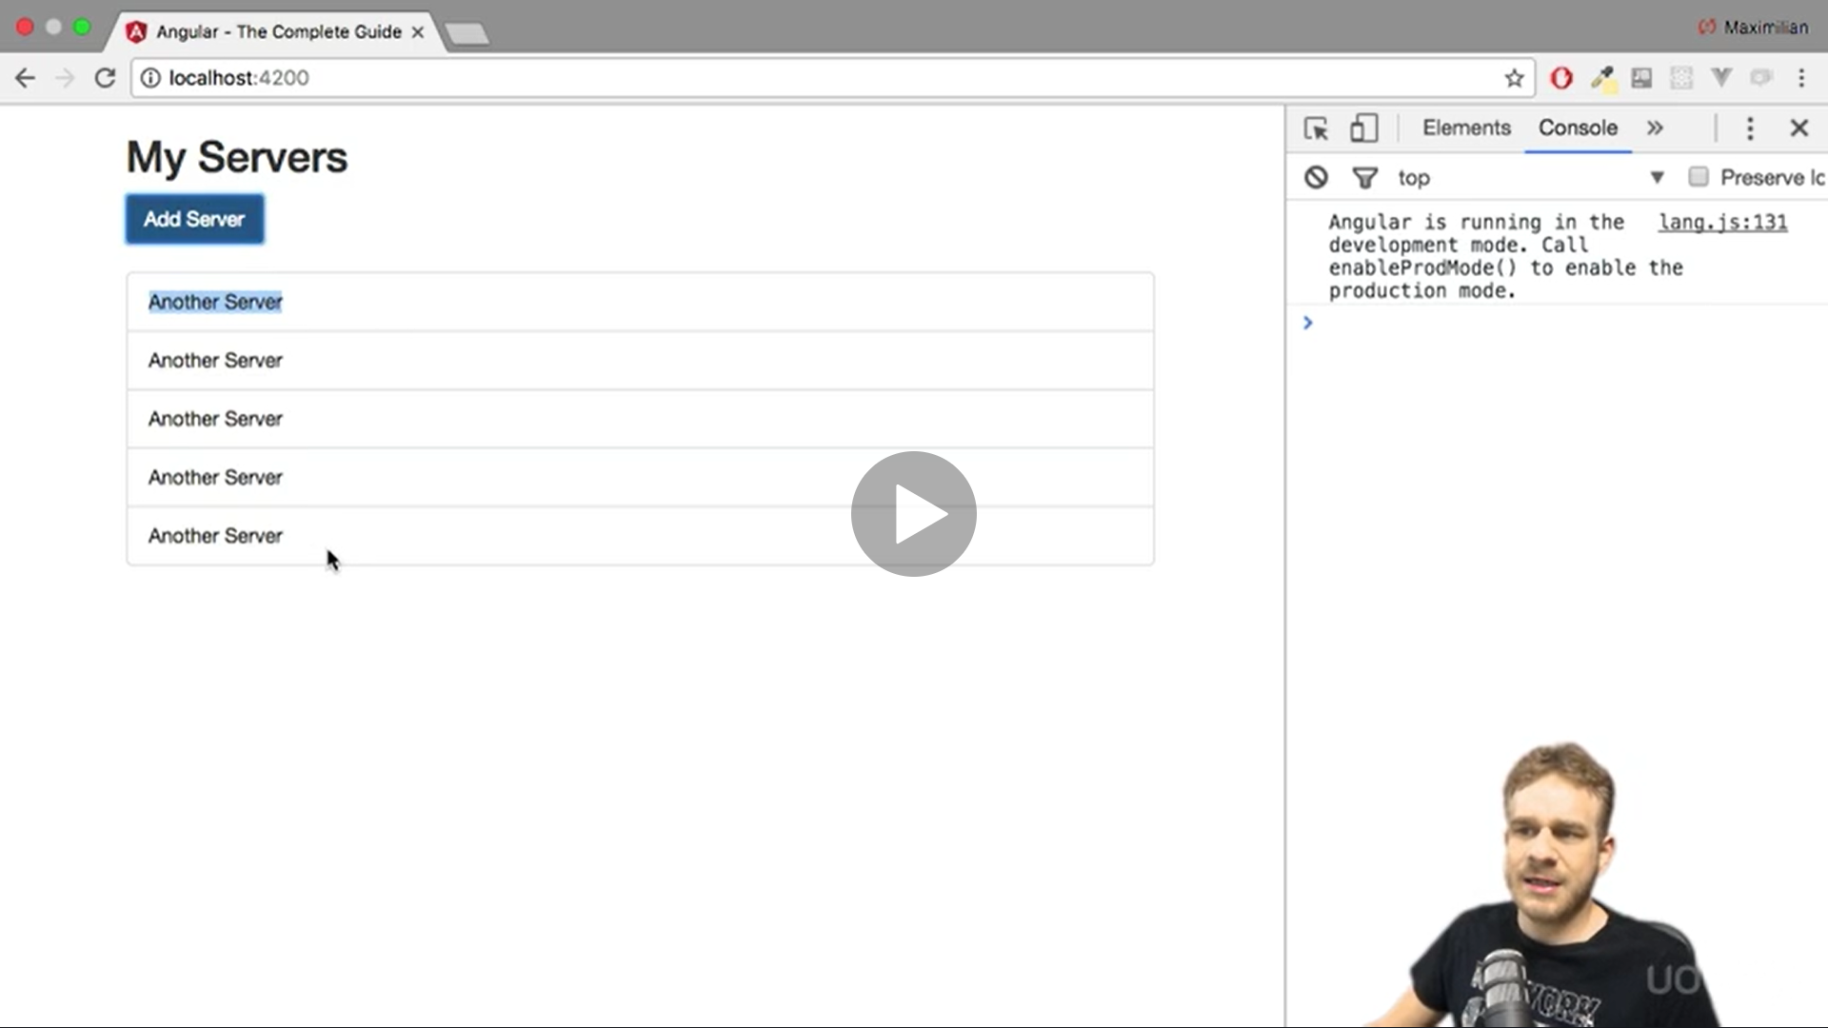

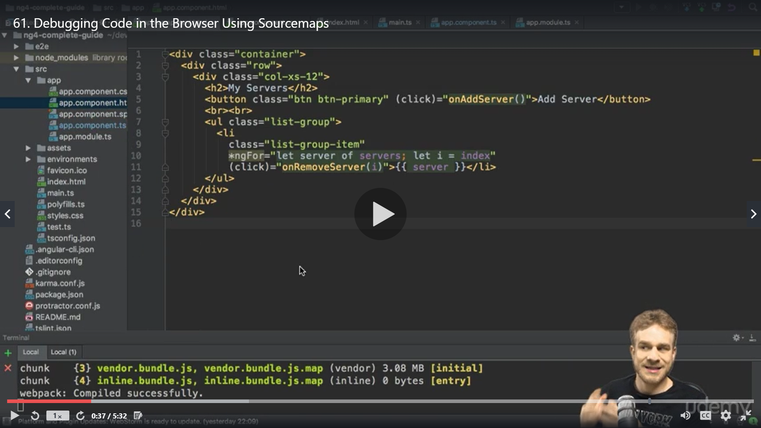

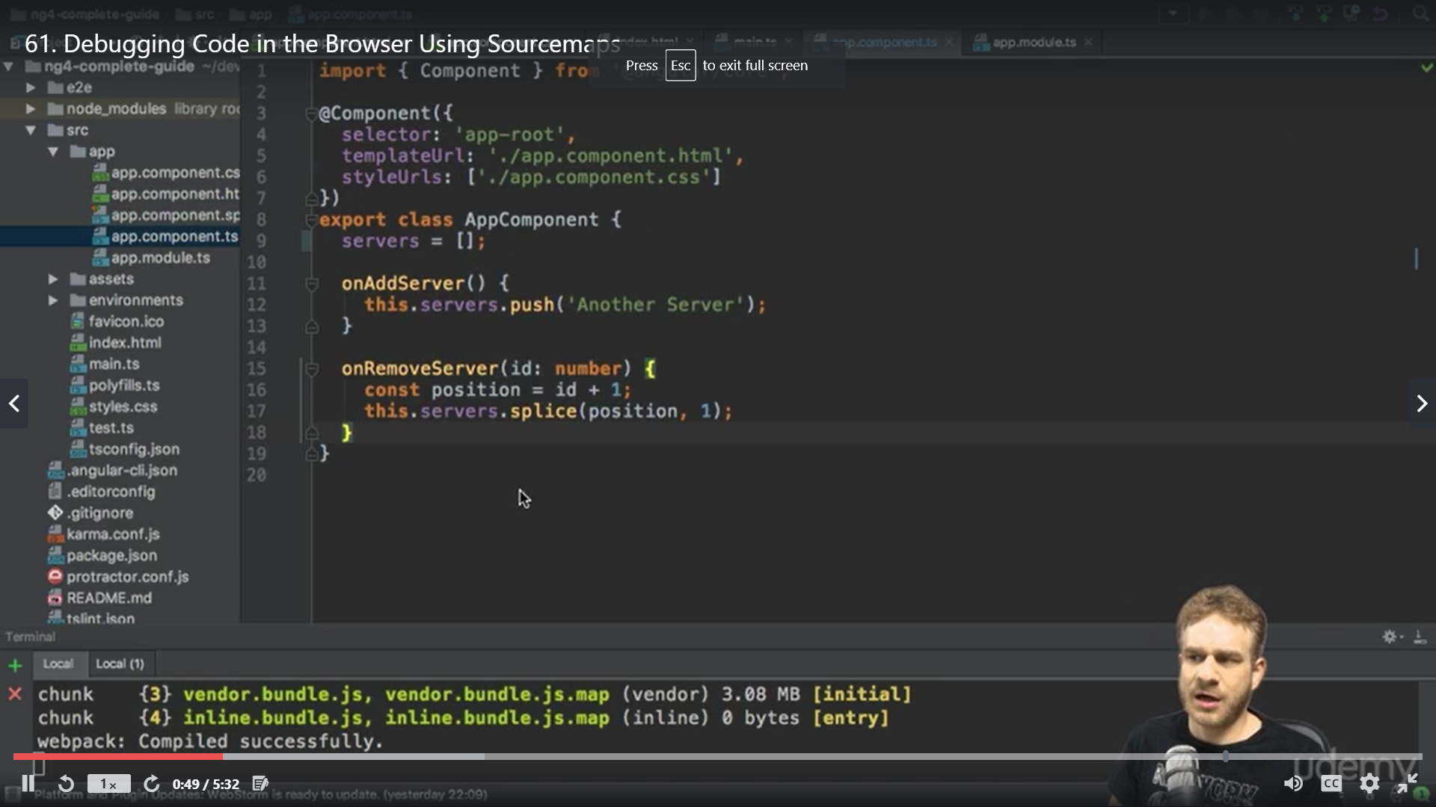

To debug logically

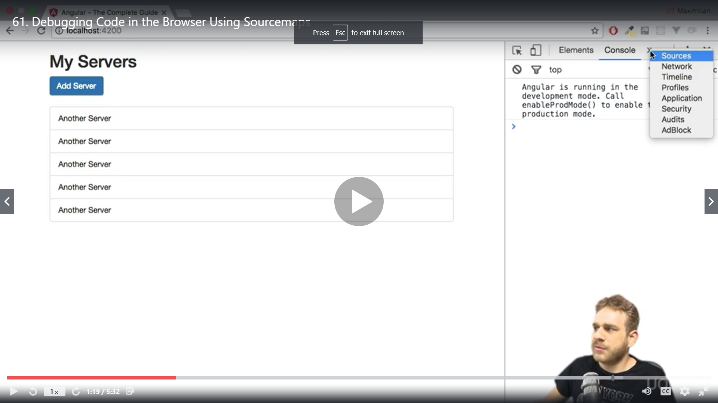

Sources>main bundle

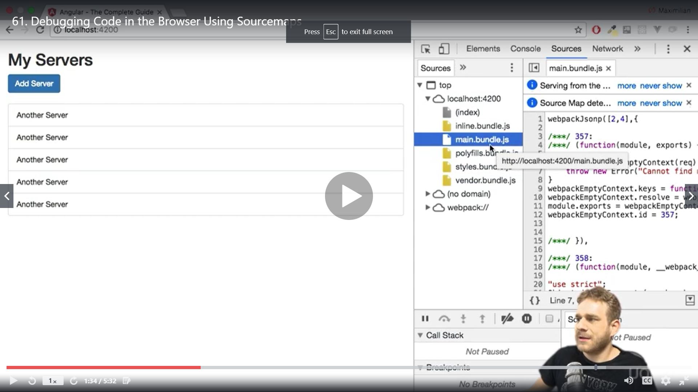

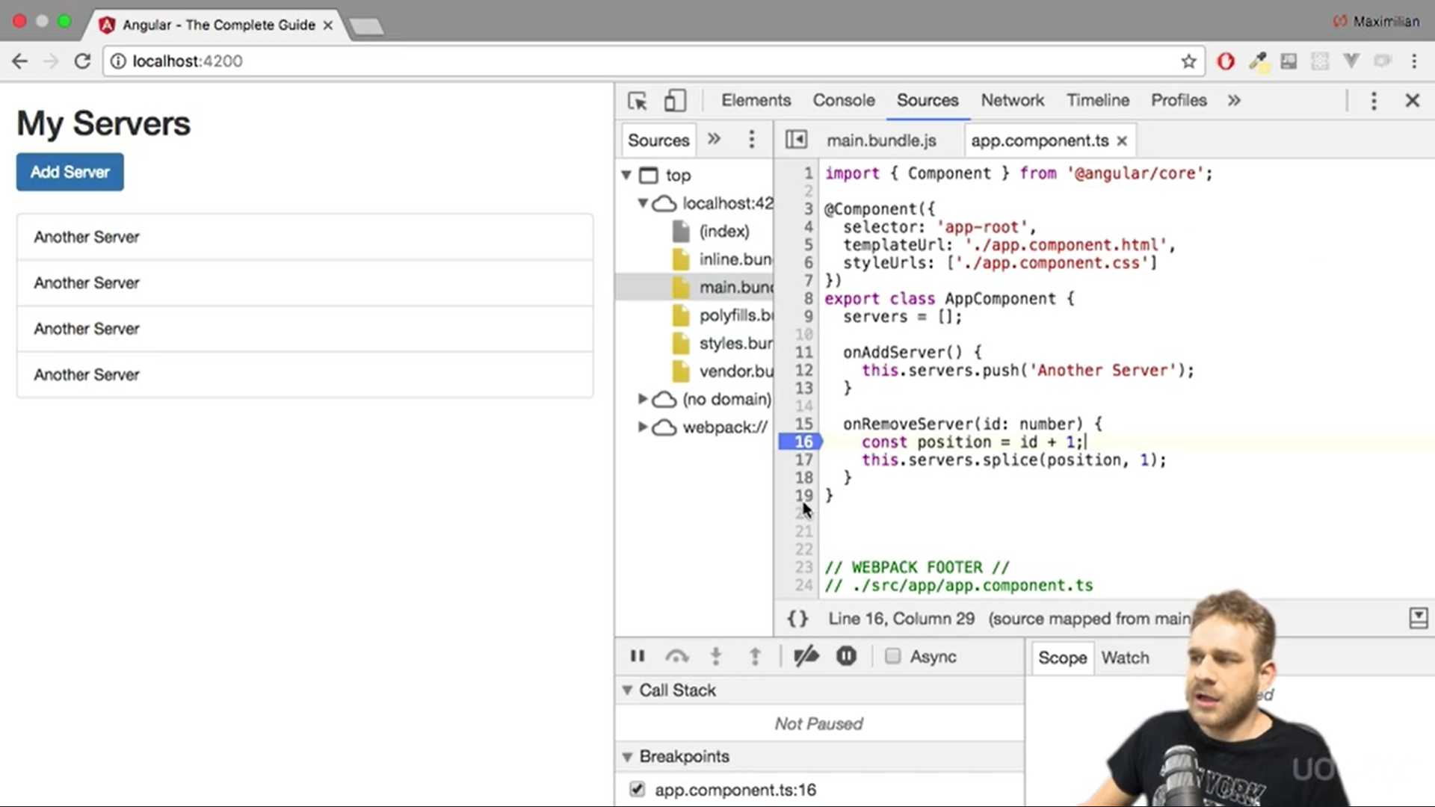

now we need to access the typescript code but Its javascript that runis runnings which support sourcemap

Source map is an addition which CLI adds to our bundle ,sourceman allows to translate /map the javascript code to our typescript in development

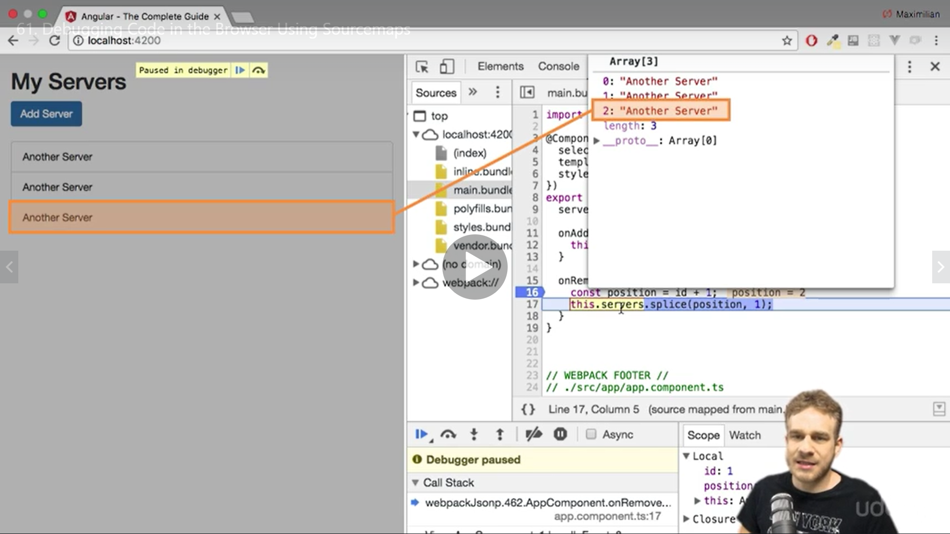 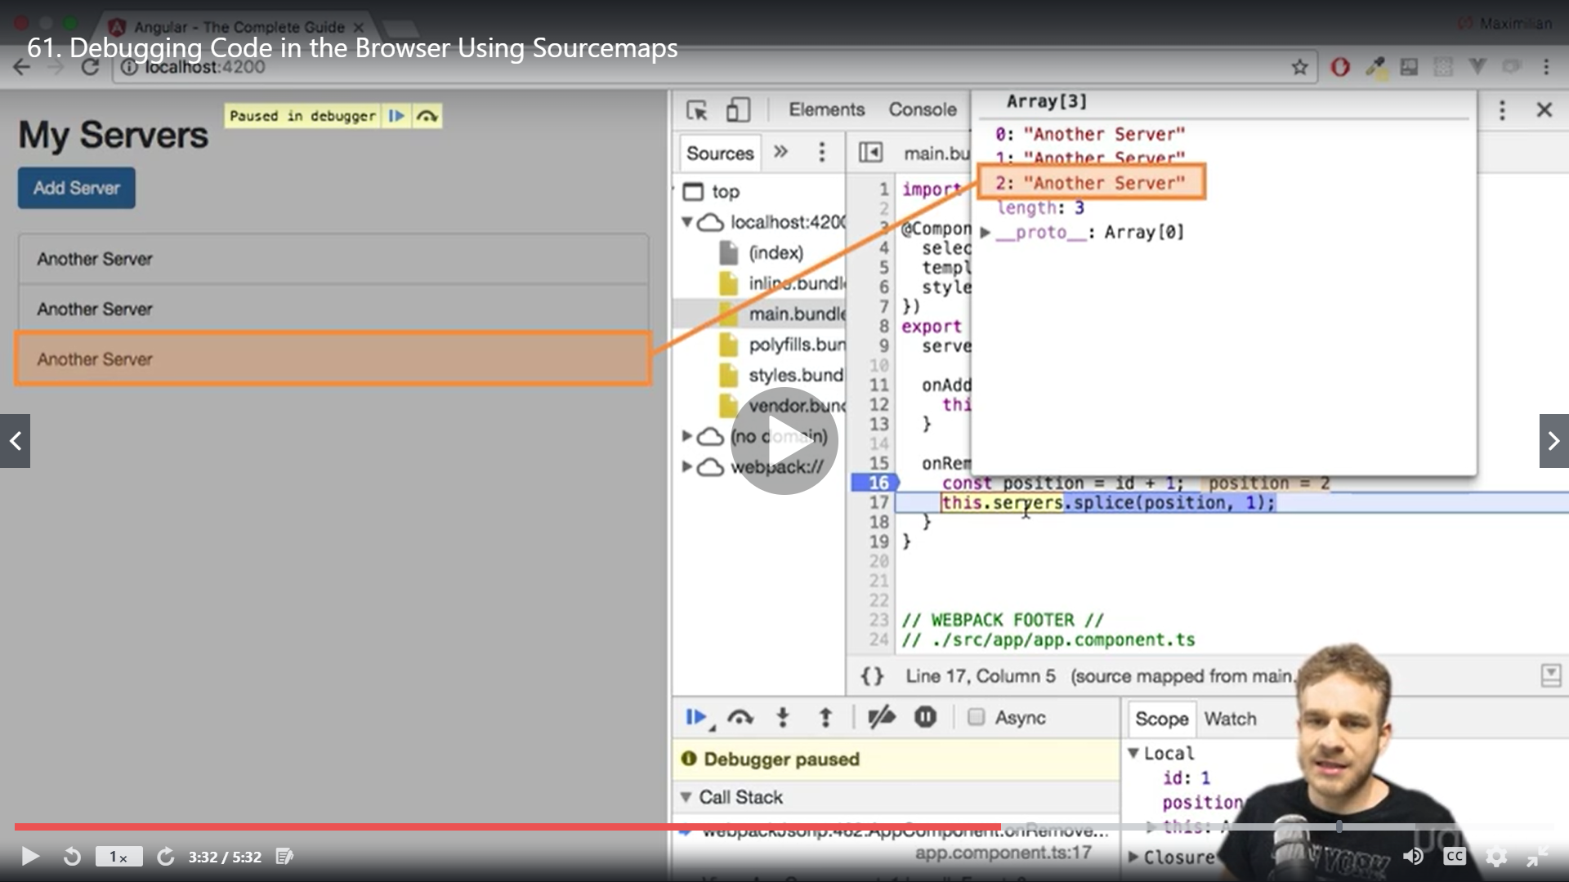

Pause and jump using debugger buttons below

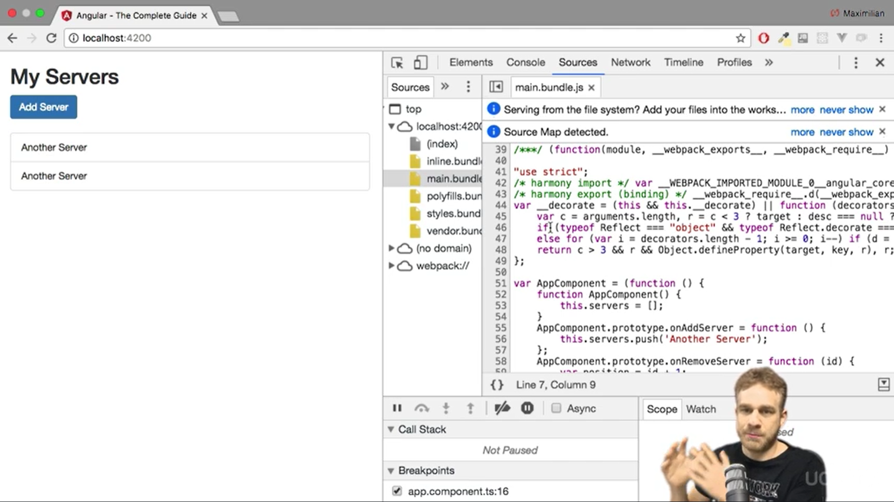

We can access our typescript files in webpack folder in same structure they were in our vs code

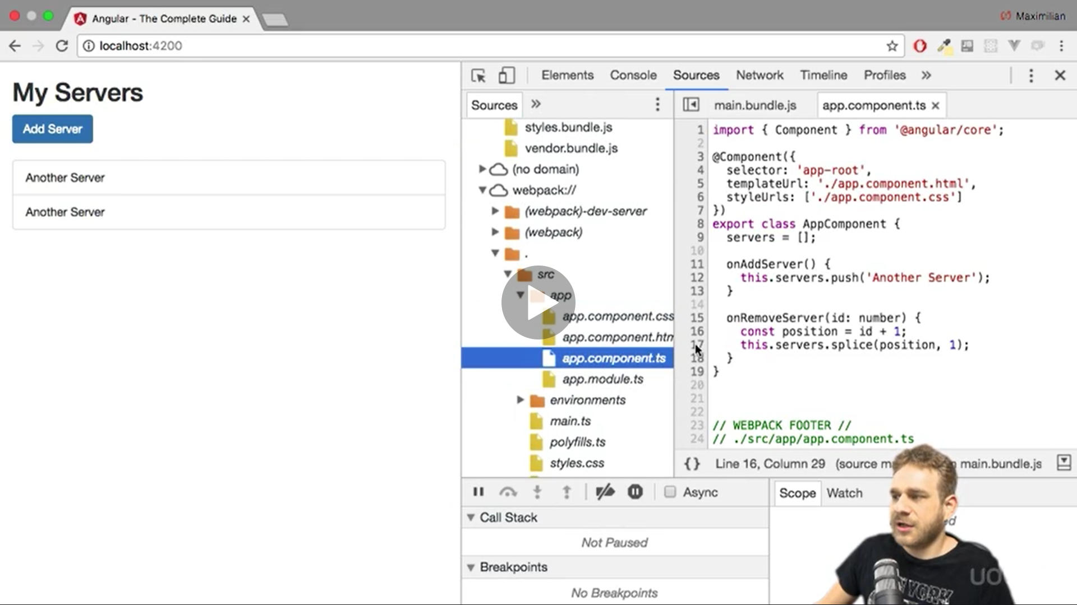

The other tools we have is angular augury

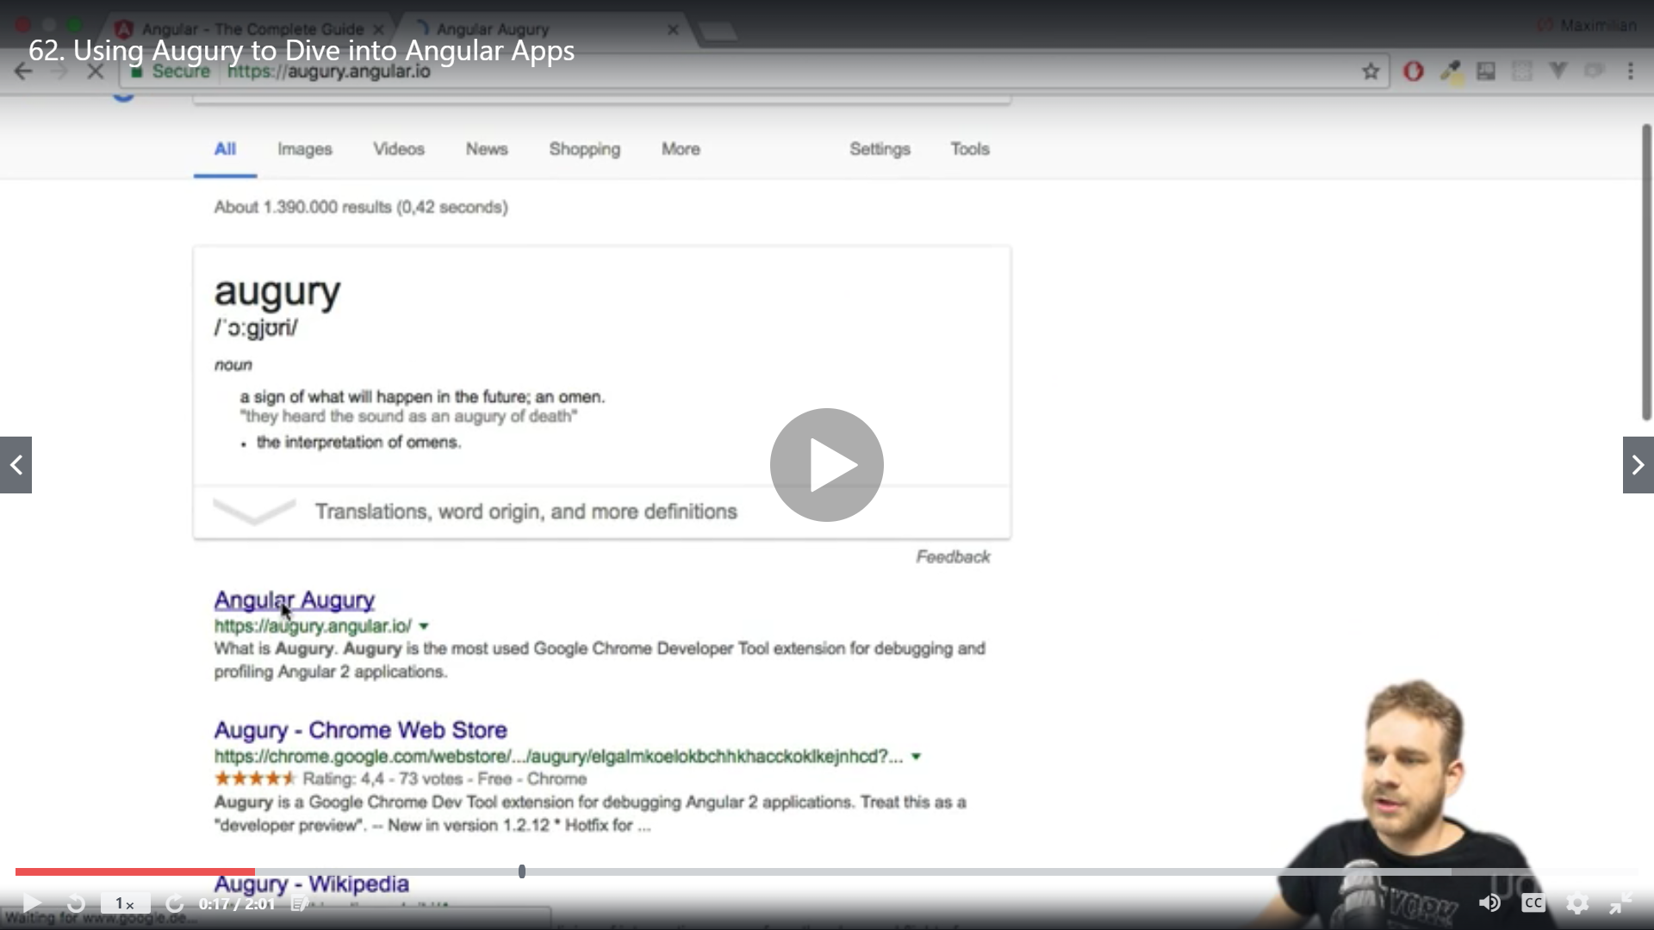

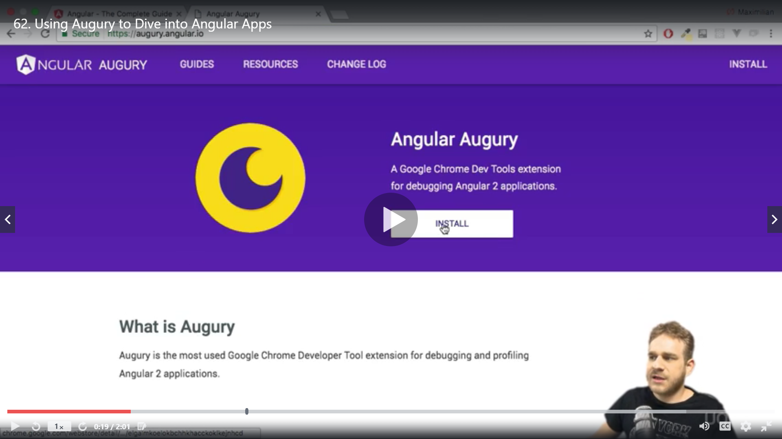

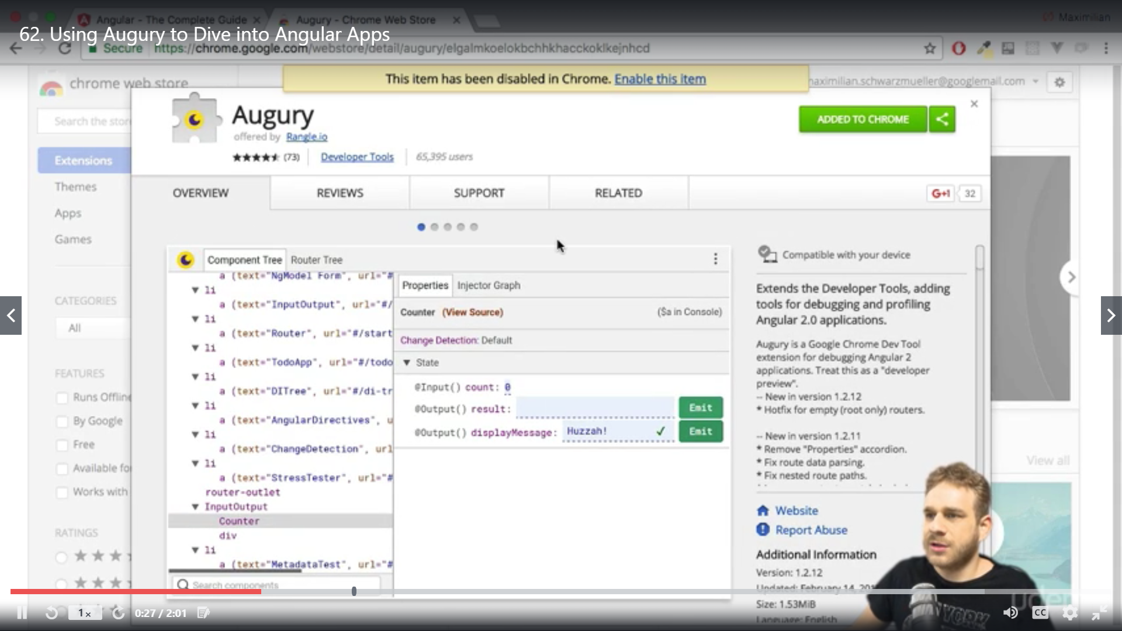

After installation you can see it in chrome

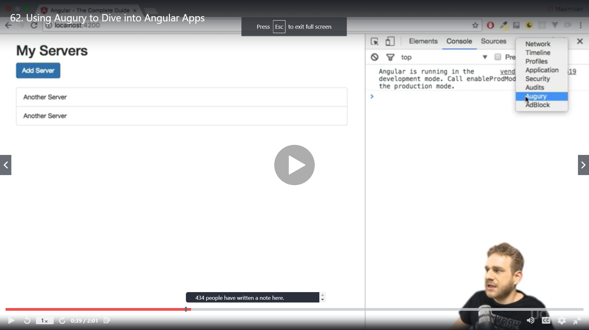

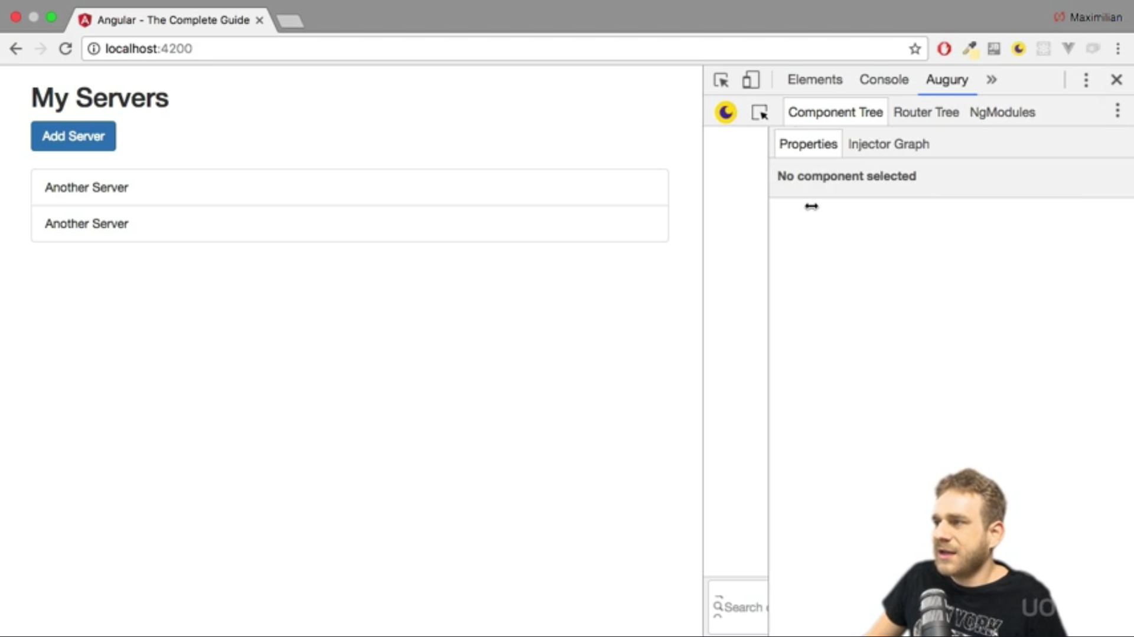

Reload the app now

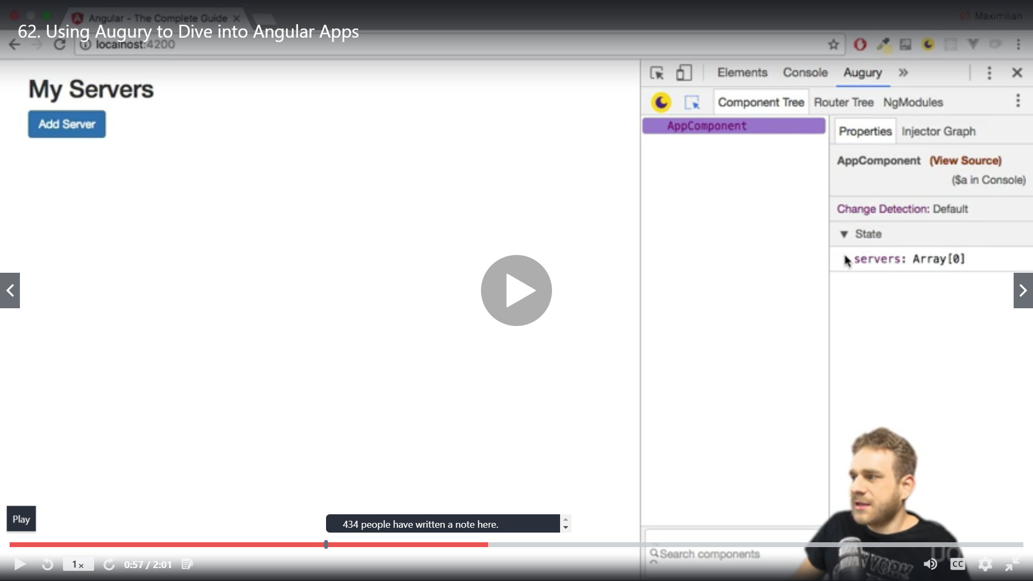

For complex applications click injector graph it will allow you to see the dependencies between your component

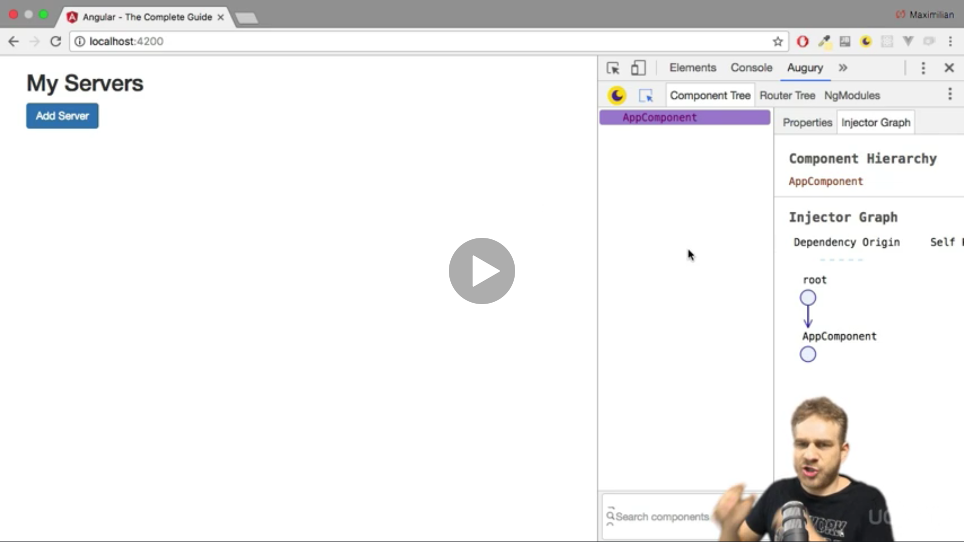

Router tree

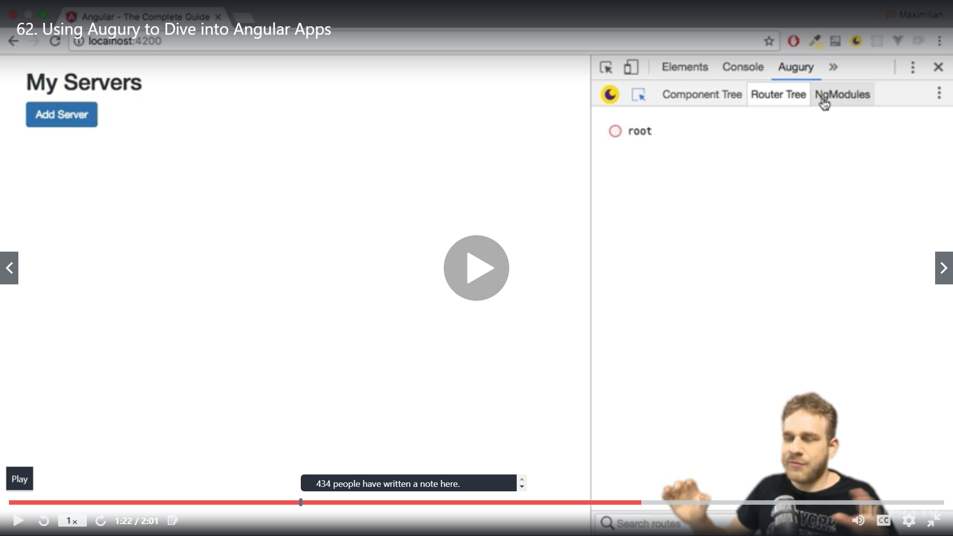

Ngmodule

